Functional Requirement Specification

Web Based Centralized E-Attendance System

Department of Information Technology, Government of Nepal

FRS Report, Version 1.1, 8-Aug-2021

Submitted by

XYZ CO

##### Document History

|  |  |  |  |  |  |
| --- | --- | --- | --- | --- | --- |
| Date | Version | Author | Reviewed by | Approved by | Description |
| 2021-01-20 | 1.0 | XYZ | ABC |  |  |
| 2021-08-08 | 1.0 | XYZ | ABC |  |  |

##### Table of Contents

1. Introduction 5

1.1. Project Background 5

1.2. Project Objectives 5

1.3. Purpose of this Document 6

1.4. Structure of this Document 6

Functional Requirements: 6

Other Requirements: 6

Operational Requirements: 7

Formatting 7

2. Functional Requirements 8

2.1 Context 8

2.2. User Requirements 9

2.3. Process Flow Diagrams 12

2.4. Functional Requirements 33

2.4.1. Functional RequirementGroup1: User Authentication/Access 33

2.4.2 Functional RequirementGroup2: Dashboard 34

2.4.3. Functional RequirementGroup3: Leave Management 38

2.4.4. Functional RequirementGroup4: Kaaj Management 39

2.4.5. Functional RequirementGroup5: Shift Management (FR: 023) 40

2.4.6. Functional RequirementGroup6: Profile and Notification Management 40

Personal Details 41

Personal Job Details 41

2.4.7. Functional RequirementGroup8: User Management (FR:026) 43

2.4.8 Functional RequirementGroup7: Settings/Configuration (FR:027) 45

2.4.8. Functional RequirementGroup8: Others 46

3. Other Requirements 48

3.1. Interface Requirements 48

3.2. Hardware Interfaces 50

3.3. Software Interfaces 50

3.4. Data Conversion Requirements 51

3.5. Hardware/ Software Requirements 51

3.5.1 Hardware Requirements 51

3.5.2 Software Requirements: 51

4. Operational Requirements 52

4.1. Security and Privacy 52

4.2. Audit Trail 53

4.3. Recoverability 53

4.4. System Availability 53

4.5. General Performance 54

4.6. Capacity 54

4.7. Data Retention 54

4.8. Error Handling 54

4.9. Validation Rules 55

4.10 Conventions/ Standards 55

APPENDIX-A-GLOSSARY 56

APPENDIX-B- Assumptions, Constraints and Non-Functional Requirements 57

Assumptions 57

Constraints 57

Non Functional Requirements 57

# 1. Introduction

This document has been created as a part of Artifacts Document. This Functional Requirement Specification (FRS), prescribed in GEA2.0 mandatory artifacts, documents the operations and activities that the system (E-Attendance System) must be able to perform.

## 1.1. Project Background

Most of the Government Organization here in Nepal have large number of employees working under various sections/departments/divisions/units etc. For all these employees, human resource department of organization needs to track their daily attendance which directly influence organization's productivity. Currently, in Department of Information Technology (DOIT) there is traditional way of logging the daily attendance manually in register sheet. This traditional method is so much time consuming and little bit hassle to manage. Thus, since Information Technology is now emerging like wave across the world contributing to make things easy to manage, DOIT is adopting the IT solution by Developing **"E-Attendance System".**

The E-Attendance System will help agency to see who is checked in and in what time. By doing this, we will be benefitted by keeping track of employee working hours. We will be ensured that we can manage employee's time effectively so that we can get most out of their time. We can maintain complete records of sick leaves and holidays, as well ensure that our employees are being paid correctly.

The E-Attendance System will include Employee Profile Management and Leave Management as Core Functional Module and will retrieve the Daily Attendance Data from Biometric Device using Web API.

## 1.2. Project Objectives

The main objective of this assignment is to develop, implement and support a centralized e-attendance system to manage employee’s attendance, leave, kaaj and profile for all government agencies which could also serve its purpose by controlling repetitive expenses on implementing same system at different government offices.

## 1.3. Purpose of this Document

This Functional Requirement Specification (FRS) document intends to provide a comprehensive description of the intended business flow and detailed functionalities of the process of **"E-Attendance System".**

This document has been prepared using the scope of work outlined in the ToR baseline and the information collected through elaborate workshops with all the relevant process owners and stakeholders.

## 1.4. Structure of this Document

This document is structured in the below mentioned way:

### Functional Requirements:

This section contains functional requirements of the system. It contains application features or functions that developers must implement to enable users to accomplish their tasks. It defines system behavior under specific conditions.

This section contains below information in chronological order:

1. Context
2. User Requirements
3. Process Flow Diagrams
4. Functional Requirements

### Other Requirements:

This section contains non-behavioral requirement of the application.

Below are the information in chronological order:

1. Interface Requirements
2. Hardware Interfaces
3. Software Interfaces
4. Data Conversion Requirements
5. Hardware/Software Requirements

### Operational Requirements:

This section contains operational requirement of the application which describe how the system will run and communicate with operations personnel.

Below are the information in chronological order:

1. Security and Privacy
2. Audit Trail
3. Recoverability
4. System Availability
5. General Performance
6. Capacity
7. Data Retention
8. Error Handling
9. Validation Rules
10. Conventions/ Standards

### Formatting

1. Style Declaration

**Font-family:** Georgia

**Font -size:** 12px

**Page Margin:** Top Left Bottom Right: 1 1 1 1

**List**: First: 1, 2,... ; Second: A,B,...; Third: I, II,...; Fourth: a, b, ...; Fifth: i, ii,....;

1. Headers

**Font Size :** H1: 28; H2: 18; H3: 16; H4: 14

**Font Style:** Bold, Italic   
**Font Style:** Overline #c00000 (RGB 192,0,0), Text Color Black H1

**Color:** #c00000 (RGB 192,0,0) H2, H3, H4,

1. Document Body

**Paragraph**: 1.25 line spacing Before/After 12px.

**Table**: Border top/bottom #c00000 (RGB 192,0,0)

# 2. Functional Requirements

## 2.1 Context

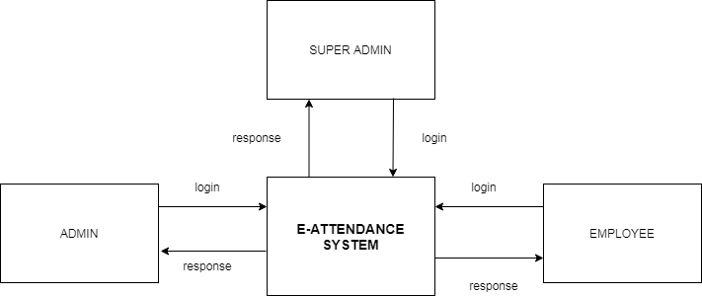

Figure 1DFD (0) User view

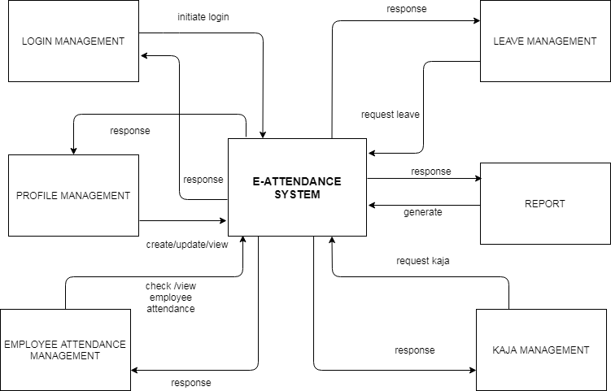

Figure 2DFD (0) Process

## 2.2. User Requirements

User Requirements for the "E-Attendance" System are listed below:

1. **User Types (UR: 001)**

There should be three types of user-types for this application i.e. Super Admin, Admin and Employee. Super Admin should have universal right for operating and managing the system. Super admin should create Admin who should have right to administer and manage the system configurations and to create other users as required. These user should be able to handle the system configurations and manage the application. In addition, Admin should have privilege to create as many user group as required.

Similarly, Employee user are those who should be created by the Admin and have right to operate the system as per the roles and permission defined to them. Employee user should have access to only those modules/functionalities in the system in which Admin have granted permission to use.

1. **Login (UR: 002)**

User should be able to log in to the system using their login credentials.

1. **Dashboard (UR: 003)**

User should be landed in the dashboard after login where they should have consolidated view of all the data from across all the interfaces of the application. This dashboard should show summary statistics of application data as mentioned below:

1. Total Employee Count
2. Total Present Employee for current date.
3. Today Absent Employee for current date.
4. Total Active/Inactive Devices
5. Total Employee in Leave
6. List of Kaaj Information
7. List of Recommended Leave Information
8. List of Leave Information
9. List of No Shift Employee
10. List of Working Timetable
11. Graphical Illustration Employee Status
12. Nepali Calendar
13. Highlighting notification message.
14. Notification

Each and every system information should be properly arranged and managed in the dashboard.

Similarly, all the system menus should be arranged in the sidebar. There should be proper placement of Logout, Profile and Change Password button. There should be highlighting notification message in the Dashboard.

User should have notification feature from which for every decisive action made on their application will be notified to them.

1. **Profile Management (UR:004)**

User should be able to update and add their own profile information. They can view own profile information on the profile page. The list of information that should be shown in the users profile page are as below:

1. Personal Details
2. Job Detail
3. Leave Detail
4. Kaaj Detail
5. Sanchit Leave Detail
6. Login Detail
7. Shift Roster
8. Spent Leave
9. Manual Attendance

Each profile information as above should be arranged in the tab with proper tab heading.

1. **Leave Management (UR: 005)**

User should be able to request leave, recommend leave and approve leave.

Admin should be able to see total number of leave taken, number of recommended leave by the employee on particular month/year.

All the leave information should be listed in the Leave Listing Page and Recommended Leave Listing Page.

1. **Kaaj Management (UR: 006)**

User should be able to request Kaaj, approve Kaaj.

Admin should be able to see the number of Kaaj taken by the employee on particular month/year.

All the Kaaj information should be listed in Kaaj Listing Page

1. **Listing Pages (UR: 007)**

Each listing pages like Employee Listing Pages, Present Employee Listing Pages , Device Listing pages should have Shorting, Search and Print feature.

1. Attendance Pull (UR: 008)

Admin should be able to view the attendance of employee within the five minutes after the biometric thumb use.

1. **Report (UR:009)**

User should be able to view, generate, filter and download the types of attendance reports as below:

1. Daily Report
2. Absent Report
3. Late Entry Report
4. Work Report
5. Monthly Attendance
6. Total Attendance
7. Annual Attendance
8. Sanchit Leave Report
9. Shift Roster Report
10. Early Exit Report
11. Monthly Early Exit/Late Entry Reports
12. **User Management (UR: 010)**

Super Admin should have universal right in the system and should create admin user. Admin should have right to add and manage employee users.

1. **Configuration Management (UR: 011)**

The system should be parameter driven where admin can update the parameter as required.

1. **User Activity Logs (UR: 012)**

Admin should be able to view the system logs like Login Logs, Failed Login Logs, User Activity Logs etc.

## 2.3. Process Flow Diagrams

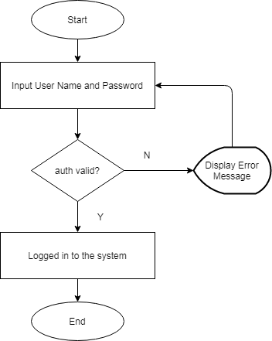

Figure 3 Login

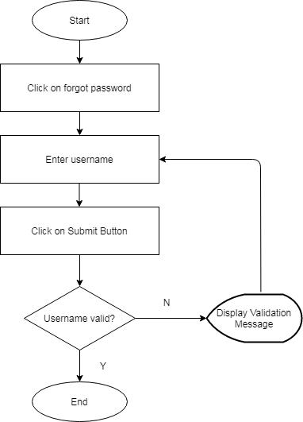

Figure 4 Forgot Password

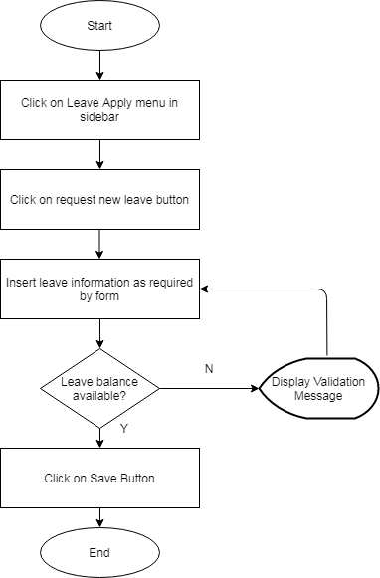

Figure 5 Leave Apply

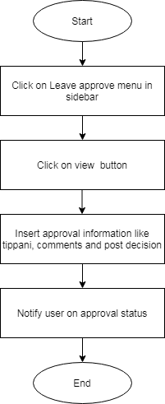

Figure 6 Leave Approve

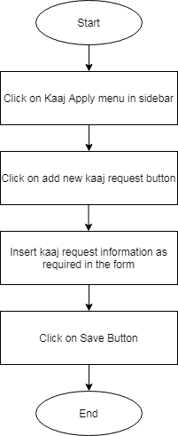

Figure 7 Kaaj Request

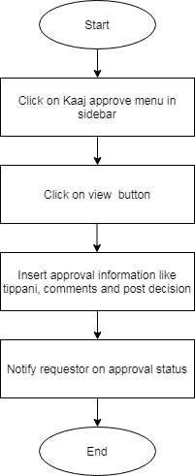

Figure 8 Kaaj Approve

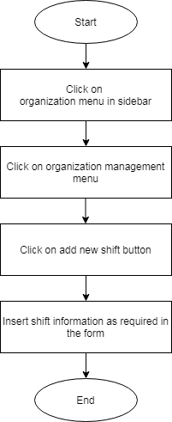

Figure 9 Organization Shift Management

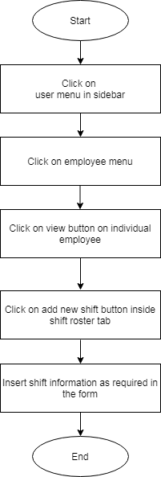

*Figure 10 Employee Shift Management*

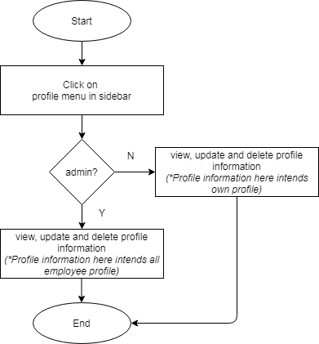

Figure 11 Profile Management

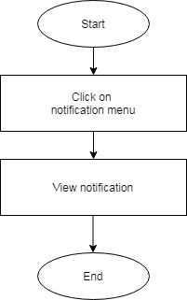

Figure 12 Notification Management

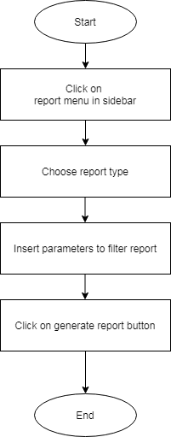

Figure 13 Reports

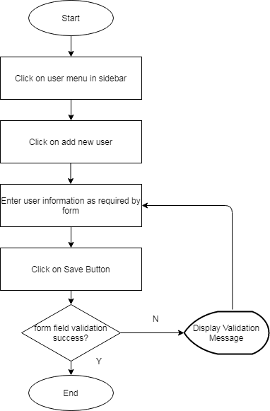

Figure 14 User Management

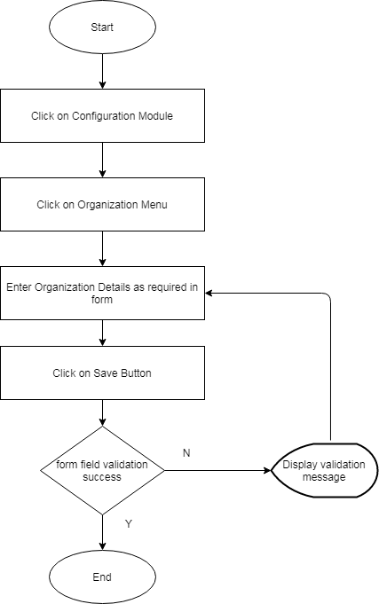

Figure 15 Configuration: Organization Management

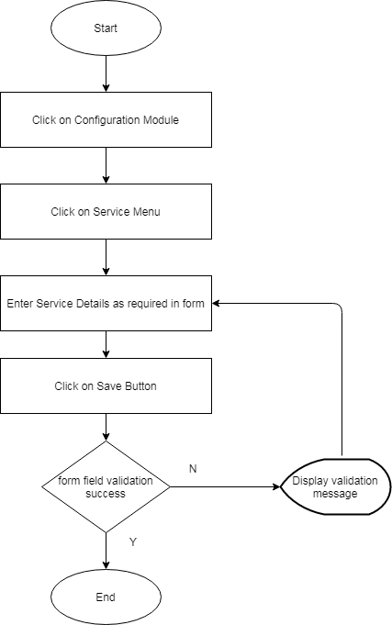

Figure 16 Configuration: Service Management

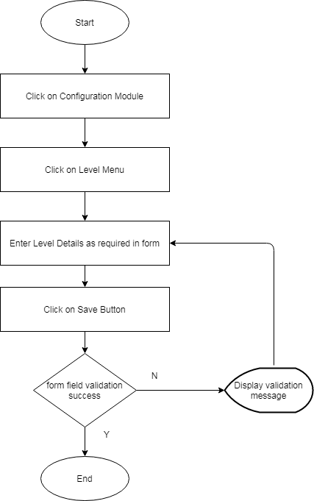

Figure 17 Configuration: Level Management

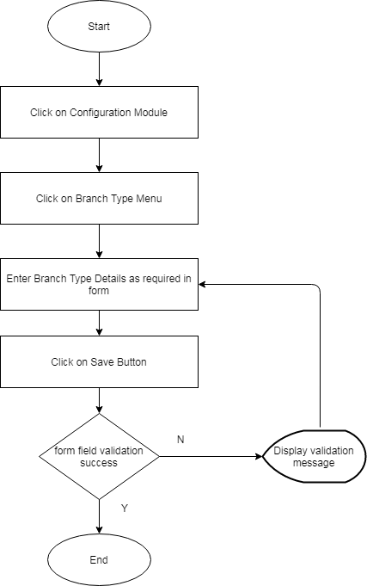

Figure 18 Configuration: Branch Type Management

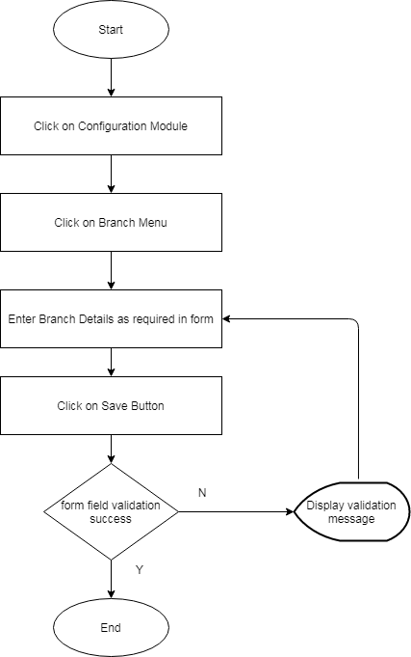

Figure 19 Configuration: Branch Management

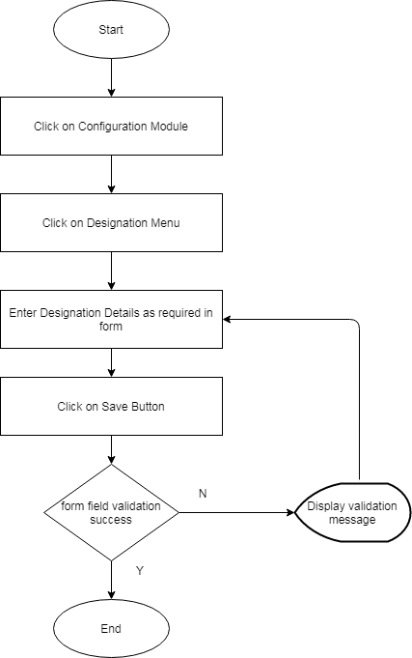

Figure 20 Configuration: Designation Management

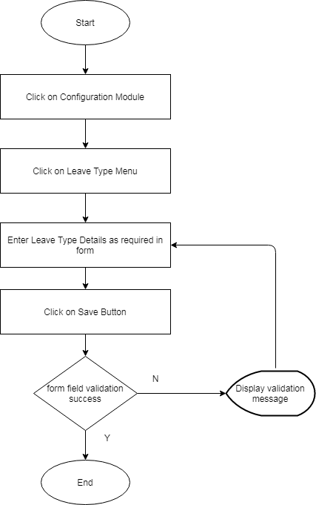

Figure 21 Configuration: Leave Type Management

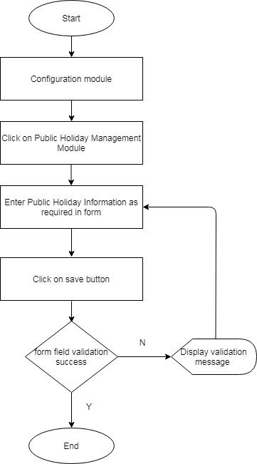

Figure 22 Configuration: Public Holiday Management



Figure 23 Configuration: Public Holiday Management

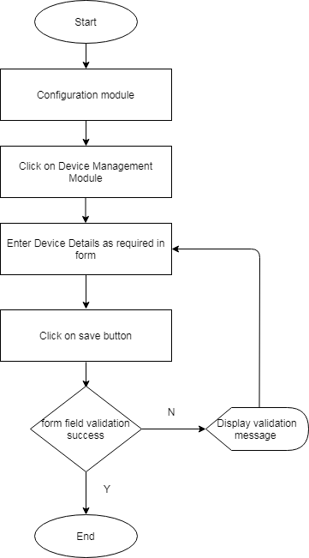

Figure 24 Configuration: Device Management

## 2.4. Functional Requirements

### 2.4.1. Functional RequirementGroup1: User Authentication/Access

#### 2.4.1.1. Login (FR: 001)

1. Login Page should have Username/Sanket Number and Password field to enter the login credentials.
2. User Name field should accept both alphanumeric value.
3. Password field should accept alphanumeric and special character. The password length should be at least six digit character.
4. Username and Password field should have proper validation defined
5. The login page should have **remember me** checkbox. Clicking the **"remember me"** box should tell the browser to save cookies so that if user close out the window without signing out, the next time user go back, s/he will be signed back in automatically.
6. Clicking the sign-in button should check the user authentication and if success the system should move the user inside system dashboard. If authentication failed, the system should flash message **“Wrong Username and Password"** and should stay in the login page**.**
7. Disclaimer or Copyright outline should be mentioned in the Login Page with proper hyperlink.

#### 2.4.1.2 Logout (FR: 002)

1. The system should have logout button/link clicking which user should be logged out from the system moved to the login page. Clicking logout button should destroy the current session and redirect to the login page.

#### 2.4.1.3 Forgot Password (FR: 003)

1. There should be a forgot password link in the login page where on clicking the link, it should redirect to Forgot Password Page
2. Forgot password page should have form containing Username field, Cancel and Submit Button.
3. On Clicking the submit button, the system should send the auto generated password over the user email if the username is valid. If not, the system should display proper error message.
4. On clicking the cancel button, the system should redirect to the login page.

#### 2.4.1.4. Password Change (FR: 004)

1. The system should have Change Password Link
2. On clicking the link, change password pop up form should be displayed.
3. The change password pop up form should have Employee information display in the left side containing the information like:
4. User Image
5. User ID
6. Username
7. Sanket Number
8. Mobile Number
9. Email
10. Change password pop up form should have password input fields on the right side containing:
11. Current Password Input Field
12. New Password Input Field
13. Confirm Password Input Field
14. Password field should accept alphanumeric and special characters and should accept minimum password length of six character.
15. The pop up form should have Submit and Cancel Button. On clicking the submit button, the system should validate the data of New Password and Confirm Password. If matched, the password should be successfully updated else the system should notify **"New Password and Confirm Password did not matched".**
16. On clicking cancel button, password should not be updated and the pop up form should be closed.

### 2.4.2 Functional RequirementGroup2: Dashboard

The Dashboard should be the landing page which should contain the statistical and graphical representation of data regarding employee attendance, leave, Kaaj, shift, Work Timetable, Employee Status, Informative Nepali Calendar with attendance flag.

#### 2.4.2.1 Total Employee Count (FR: 005)

1. The Dashboard should show total number of employee along with link to employee details page
2. On clicking the show details, the system should navigate the user inside the employee listing page.

#### 2.4.2.2 Total Present Employee Count (FR: 006)

1. The Dashboard should show total number of present employee with link to present employee details page. It should also show the numbers for both Total Present Male and Female.
2. On Clicking the Show Details, the system should navigate user inside the Present Employee Listing Page

#### 2.4.2.3 Total Device Count (FR: 007)

1. The Dashboard should show total number of Active/Inactive Devices along with link to the Device Details page
2. On clicking the view details, the system should navigate user inside the Devices listing Page.

#### 2.4.2.4 Total Present Employees Count (FR: 008)

1. The Dashboard should show total present employee count

#### 2.4.2.5 Total Absent Employees Count (FR: 009)

1. The Dashboard should show total absent employee count

#### 2.4.2.6 Total Employee in Leave Count (FR: 010)

1. The Dashboard should show total employee in leave count.

#### 2.4.2.7List view of Rejected and Pending Kaaj(FR: 011)

1. The Dashboard should show Total Count of Rejected Kaaj and Pending Kaaj
2. The list of Kaaj records should be displayed in tabular view with below mentioned column heading:
3. ID
4. Office
5. Employe Sanket Number
6. Employee Name
7. Type
8. Place
9. Application Date
10. Start Date
11. End Date
12. Approved by
13. Country
14. Status
15. Action : view
16. On Clicking the view button, the user should be navigated to the Kaaj Detail Page

#### 2.4.2.8List view of Rejected and Pending Recommended Leave (FR: 012)

1. The Dashboard should show Total Count of Rejected Recommended Leave and Pending Recommended Leave
2. The list of recommended leave records should be displayed in tabular view with below mentioned column heading:
3. ID
4. Office
5. Employee Sanket Number
6. Employee Name
7. Leave Type
8. Application Date
9. Start Date
10. End Date
11. Recommended By
12. Recommendation Date
13. Status
14. Action : view
15. On Clicking the view button, the user should be navigated to the Recommended Leave Detail Page

#### 2.4.2.7 List view of Rejected and Pending Leave (FR: 013)

1. The Dashboard should show Total Count of Rejected Leave and Pending Leave
2. The list of Approved Leave records should be displayed in tabular view with below mentioned column heading:
3. ID
4. Office
5. Employee Sanket Number
6. Employee Name
7. Leave Type
8. Application Date
9. Start Date
10. End Date
11. Approved By
12. Approved Date
13. Status
14. Action : view

#### 2.4.2.8 List view of "No Shift" Employee (FR: 014)

1. The Dashboard should show total count of "No Shift" Employee
2. The list of "No Shift" Employee records should be displayed in tabular view with below mentioned column heading:
3. Employee Name
4. Designation

#### 2.4.2.9 List view of Working Timetable (FR: 015)

1. The Dashboard should show total count of Employee Working Timetable
2. The list of Employee Working Timetable should be displayed in tabular view with below mentioned column heading:
3. Employee Name
4. Designation
5. Time of Entry
6. Time of Exit

#### 2.4.2.10 Employee Status View (FR: 016)

1. The Dashboard should show the Employee Status in Graphical Format
2. The format should have below information:
3. Employee in Kaaj count on hover
4. Employee in Leave count on hover
5. Current Present Employee count on hover
6. Current Employee Late Entry on hover

#### 2.4.2.11 Nepali Calendar View (FR: 016)

1. The Dashboard should show Nepali Calendar with properly manageable Public Holidays, Flags for Employee Attendance.
2. Calendar should be displayed for current month

#### 2.4.2.12 Scrolling Text(FR: 017)

1. The Dashboard should display flash message which should be dynamically manageable.

### 2.4.3. Functional RequirementGroup3: Leave Management

#### 2.4.3.1 Leave Apply (FR: 018)

1. System should have Leave Request module to apply leave
2. On clicking the module, the system should display the leave page with tabular view of applied leave information along with view and delete feature for each information in row.
3. On clicking view, detail leave information should be displayed in form. Similarly, on clicking delete the information should be deleted.
4. In addition, the leave page should have Add New Leave, Export and Search Feature.
5. On clicking Add new leave button, the leave application form should be pop up containing the below fields:
6. Type of Leave
7. Leave Start Date
8. Leave End Date
9. Leave Approve Person
10. Reason for Leave
11. Total Leave to apply
12. Leave Recommendation Person
13. Form Upload
14. Leave Details
15. While applying leave, the system should check leave balance
16. The system should perform leave validation on submission
17. The form should contain Cancel and Submit Button
18. On Clicking the Submit Button, the leave request form should be submitted to the approval user.
19. On Clicking the Cancel Button, the leave request form should be closed.
20. Similarly, on clicking the Export button, system should export the leave details in csv format.
21. Similarly, on searching data, system should display the searched result.

#### 2.4.3.2 Leave Approval (FR: 019)

1. The system should display list of leave to be approved by current user. The list should contain latest 20 data.
2. The system should have view option to see the applied leave details
3. On clicking the view, pop up form should be displayed having fields like Tippani, Approval user and Status.
4. The form should have the cancel button to cancel the leave approval process.

#### 2.4.3.3 Leave Recommendation (FR:020)

1. The system should display list of recommended leave. The list should contain latest 20 data.
2. The system should have view option to see the recommended leave details
3. On clicking the view, pop up form should be displayed having the fields like Leave Type, Half Day Leave, Leave Year, Status, Leave Start Date, Leave End Date, Recommendation Date, Form Upload.
4. The form should have the cancel button to cancel the process.

### 2.4.4. Functional RequirementGroup4: Kaaj Management

#### 2.4.4.1 Kaaj Apply(FR: 021)

1. System should have Kaaj Request module to apply Kaaj
2. On clicking the module, the system should display the Kaaj page with tabular view of applied Kaaj information along with view and delete feature for each information in the row.
3. On clicking view, detail Kaaj information should be displayed in form. Similarly, on clicking delete the information should be deleted.
4. In addition, the leave page should have Add New Kaaj, Export and Search Feature.
5. On clicking Add New Kaaj, Kaaj application form should pop up containing the below fields:
6. Type of Kaaj
7. Year of Apply
8. Kaaj/Training Subject
9. Kaaj/Training Subject (Short Name)
10. Kaaj/Training Expense (Yes/No)
11. Kaaj/Training National (Yes/No)
12. Kaaj Start Date
13. Kaaj End Date
14. Type of Vehicle
15. Country
16. Kaaj/Training Objective
17. Kaaj/Training Place
18. Form Upload
19. The form should contain Cancel Button to cancel the Kaaj application process.
20. Similarly, on clicking the Export button, system should export the Kaaj details in csv format.
21. Similarly, on searching data, system should display the searched result.

#### 2.4.4.2 Kaaj Approval (FR: 022)

1. The system should display list of Kaaj to be approved by current user. The list should contain atleast 20 data.
2. The system should have view option to see the Kaaj details
3. On clicking the view, pop up form should be displayed having fields like Tippani, Approval user and Status.
4. The form should have the cancel button which will cancel the approval process.

### 2.4.5. Functional RequirementGroup5: Shift Management (FR: 023)

1. The system should allow admin to allocate employee shift as well as view employee shift.
2. The system should allow employee to view their shift

### 2.4.6. Functional RequirementGroup6: Profile and Notification Management

#### 2.4.6.1 Profile Management (FR: 024)

1. The system should allow user to view and update Employee Profile in each tab. On clicking each tab, the information should be loaded.
2. The system should display the employee profile details. The profile details should contain:
3. Personal Details : The system should show below data in personal details:

**Personal Details**

1. Employee Image
2. Employee Name in English
3. Employee Name in Devnagiri
4. Employee Date of Birth
5. Employee Sanket Number
6. Employee Mother Tongue
7. Employee Blood Group
8. Employee Gender
9. Employee Marital Status
10. Employee Email
11. Employee Mobile
12. Employee Date of Joining

**Personal Job Details**

1. Employee Designation
2. Employee Department/Section
3. Employee Office
4. Employee Office in Devanagiri
5. Employee Office Code
6. Employee Office Address
7. Job Details:
8. The system should show job details information. The system should allow Employee to update and view job details.
9. The system should have view and edit button for each row of list
10. On clicking the view button, the system should pop up the form where inserted employee job details should be shown. There should be cancel button in the form.
11. On clicking the edit button, the pop up form should be populated and can be editable. The pop up form should have Cancel and Update button.
12. Leave Details:
13. The system should show the list of all the leaves taken by employees. This feature should be available for admin. The system should allow admin to view leave list taken by employees. For individual employee, the system should show leave list of their own.
14. The system should have delete button for each list in the row.
15. The list column should have data like Employee ID, Office, Leave Type, Apply Date, Start Date, End Date, Recommended by, Approved by, Status, Action.
16. Kaaj Details:
17. The system should show the list of all the Kaaj taken by employees. This feature should be available for admin. The system should allow admin to view Kaaj list taken by employees. For individual employee, the system should show Kaaj list of their own.
18. The system should have delete button for each list in the row which on clicking should delete the information.
19. The list column should have data types like Employee ID, Office, Kaaj Type, Kaaj Location, Apply Date, Start Date, End Date, Approved by, Status, Action.\
20. Sanchit Leave Details
21. The system should show the list of all the Sanchit Leave taken by employees. This feature should be available for admin as well as employee also.
22. The system allow Admin to view the list of all the employee Sanchit List. Similarly, for individual employee user, the system should allow to view list of Sanchit Leave of their own
23. The system should have edit, view and delete button for each list in the row.
24. On clicking the view, the system should show pop up form with below information:

* Name of Employee with Employee Code
* Leave Type
* Year
* Total Leave

1. On clicking the edit button, the system should pop up the form where user can edit the data
2. The pop up form for view should have Cancel Button
3. The pop up form for edit should have Update Button also
4. Login Details
5. The system should allow to view, reset password and update the login details
6. The login details page should also have print and export button. On clicking print button, system should generate print preview. Similarly, on clicking export button, system should export the information in csv format.
7. Shift Roster
8. The system should allow to view and add the shift Roster. There should be add new button in the shift Roster page where on clicking the button, Add New Shift pop up form should be populated.
9. Add new shift pop up form should contain date calendar field to choose range of date. Also , it should contain control to manage shift under proper shift heading from Sunday to Friday
10. The form should also contain Cancel and Save button. On clicking Cancel, the shift management process should end. Similarly, on clicking Save, the added shift detail should be saved.
11. Spent Leave
12. The system should allow Admin to add and update spent leave details. On clicking the add new leave information, pop up form should be displayed with below fields:

* Employee Name
* Leave Type
* Year
* Total Leave Count
* Tippani

1. The pop up form should have cancel and save button. On clicking the cancel, the form should be closed whereas clicking save button should save the information in the database.

#### 2.4.6.2 Notification Management(FR: 025)

1. The system should notify users in below mentioned action:
2. Leave Approval
3. Leave Recommendation
4. Kaaj Approval
5. Kaaj Recommendation
6. The system should show notification on Leave Approve/Reject, Kaaj Approve/Reject, Recommended Leave Approve/Reject

### 2.4.7. Functional RequirementGroup8: User Management (FR:026)

1. The system should have feature to create the user.
2. The User Page should have list of all created users along with create new user function, import function, search function, filter function
3. On clicking the Create new user button, the user should be navigated to the Add new user form
4. Add new user form should have below mentioned input fields:
5. Login Information

Login Information should contain below fields:

1. Login Office
2. Login ID
3. System Role
4. System Language
5. Personal Information
6. Device ID
7. Employee Sanket Number
8. Employee Name (English)
9. Employee Name (Nepali)
10. Gender
11. Birth Place
12. Mobile Number
13. Email
14. Marital Status
15. Date of Joining
16. Employee Current Designation Date
17. Mother Language
18. Blood Group
19. Religion
20. Date of Birth
21. Physically Disable -Yes/No
22. Personal Details
23. Image Upload
24. The system should check for below validation while creating the user:
25. Login Duplication Check
26. Sanket Number Duplication Check( i.e. Sanket Number should be unique)
27. Email Validation
28. The pop up form should have save and cancel button. On clicking save, the information should be saved in the database whereas on clicking cancel will cancel the user creation process.
29. All the created user should be listed in the User page.
30. User page should have **Add new**, **Export** and **Print Button.**
31. User Page should have "Create Leave" and "Create Kaaj" function for each row in the list
32. User page should have edit button for each row in the list
33. On clicking the Print/Export button, pop form should be displayed with Employee List as preview. The pop up form should have cancel button to close the pop up form.
34. On clicking the Print button, the system should originate print preview where user can print the document
35. System should have option to allow user information search.
36. The search results should be allowed to be sorted by ASC/DESC.
37. The Users listing/records should be paginated allowing to navigate through different pages/listing.
38. User page should list the added user information in tabular form with below mentioned column heading:
39. ID
40. Employee Sanket Number
41. Gender
42. Designation
43. Date of Joining
44. Office
45. Department/Section
46. Mobile
47. Status
48. Role
49. Leave/Kaaj Create Function
50. Action : Edit Function

### 2.4.8 Functional RequirementGroup7: Settings/Configuration (FR:027)

The system should have option to add and manage below configurations:

1. Organization Detail
2. Service
3. Position
4. Department Type
5. Department
6. Designation
7. Leave Type
8. Role Type
9. Public Holiday
10. Attendance Device
11. Shift Management
12. Shift Roster

### 2.4.8. Functional RequirementGroup8: Others

#### 2.4.8.1 Reports(FR:028)

1. The system should allow to generate customizable reports.
2. The system should show below reports:
3. Daily Report
4. Absent Attendance Report
5. Late Entry Report
6. Work Report
7. Monthly Attendance Report
8. Monthly Attendance Detail Report
9. Total Attendance Report
10. Annual Attendance Report
11. Annual Attendance Detail Report
12. Monthly Leave Report
13. Sanchit Leave Report
14. Monthly Kaaj Report
15. Shift Roster Report
16. Early Exit Report
17. Monthly Early Exit/Late Entry Report
18. The system should allow users to export the reports in PDF, Excel Format
19. The system should have filter option to filter the reports as per the parameter like Date Wise, Fiscal Year Wise, Employee Name, Attendance Type (Daily, Monthly, Yearly), Late Entry, Early Exit

#### 2.4.8.2 Device Management (FR:029)

The system should have option to add the device details like Device ID, Office Name, Device Name, Model, IP, Port, Device Darta no, Serial No., Status

#### 2.4.8.3 Late Entry Approval (FR:030)

1. The Late Entry page should display late entry information with below mentioned column heading:
2. ID
3. Employee Sanket Number
4. Employee Name
5. Designation
6. Department/Section
7. Date
8. Check in Time
9. Checked in Time
10. Late Entry
11. Late Entry Reason
12. Tippani
13. Status
14. Action: view

#### 2.4.8.2 Early Exit Details (FR:031)

1. The Early Exit page should display early exit information with below mentioned column heading:
2. Employee Sanket Number
3. Employee Name
4. Designation
5. Date
6. Check in Time
7. Check out Time
8. Checked in Time
9. Checked out Time
10. Early Exit
11. Early Exit Reason
12. Status
13. Action: view

# 3. Other Requirements

## 3.1. Interface Requirements

Below are the interface that are needed in the E-Attendance System:

1. Login Interface

This interface should contain below functionalities:

1. User Name/Sanket Number Input Field
2. Password Input Field
3. Declaimer Message: Copyright to DOIT
4. Proper Label: Username/Employee Sanket Number ; Password
5. Sign in Button
6. Remember me checkbox
7. Forgot Password
8. Username field with proper label along with footnote
9. Cancel and Submit button
10. Change Password
11. In left component: User Image, User Name, Sanket Number, ID, Employee Sanket Number, Mobile, Email
12. In right component : Current Password field, Password field, Confirm Password field
13. On Pop up page footer: Cancel Button and Submit Button
14. Dashboard

**In Body:**

1. Component Box for showing Total Employee, Present Employee, Active/Inactive Devices, Employee in Leave Count
2. Listing of all the Rejected/Pending Kaaj in separate Component
3. Listing of all the Rejected/Pending Leave in separate component
4. List of all the Rejected/Pending Recommended Leave in separate component
5. Listing of No shift Employee in separate component
6. Listing of working timetable in separate component
7. Display of Graph for Employee Status
8. Nepali Calendar display

**In Sidebar:**

1. Module Listing: Home, Users, Reports, Help, Configuration, Settings

**In Header:**

1. Notification
2. Change Password
3. Profile
4. Logout
5. Employee Profile

**In Left Component:**

1. Users Image
2. Name
3. Designation
4. ID
5. Employee Sanket Number
6. Device ID
7. Religion
8. Mobile
9. Date of Joining
10. Office Code

**In Right Component :**

1. Tab View : Personal Details, Job Details, Leave Details, Kaaj Details, Sanchit Leave Details, Login Details, Shift Roster, Spent Leave, Manual Attendace
2. On each tab, the information should be shown as per FR: 024
3. User Management
4. Sidebar in the left side with Users Module, Request Module (Leave/Kaaj), Approve Module (Leave, Kaaj, Late Entry, Early Exit), Recommendation Module (Leave)
5. On page header: Import/Print Button, List Sorting, Filter, Search
6. On page body: Employee Information List. The list should contain information with below column heading:
7. ID
8. Employee Sanket Number
9. Employee Name
10. Gender
11. Designation
12. Date of Joining
13. Office
14. Department/Section
15. Mobile
16. Status
17. Role
18. Create Leave/Create Kaaj
19. Edit button
20. Leave Request Module
21. Reports
22. List of all the reports page in the sidebar
23. All the reports information in the bodys
24. Leave Apply
25. Kaaj Apply

## 3.2. Hardware Interfaces

The system should support below hardware interfaces:

|  |  |
| --- | --- |
| Interface Name | Physical address |
| USB port | Physical address 1 |
| Ethernet Interface | Physical address 2 |
|  | Physical address n |

## 3.3. Software Interfaces

*This application "centralized e-attendance system" is standalone application and is not engaged with other application software for any kind of data exchange and interface use.*

**Name the applications with which the subject application must interface. State the following for each such application: name of application, external owner of application, interface details (only if determined by the other application).**

## 3.4. Data Conversion Requirements

1. Every employee data should be associated with employee sanket number
2. Employee sanket number should be unique
3. Date and Time data should be in 24 hr format

## 3.5. Hardware/ Software Requirements

This section describes description of hardware/software requirements needed to operate the application.

## 3.5.1 Hardware Requirements

1. **Biometric Attendance Device Requirement**
2. Processor: 1.5 Ghz or higher CPU
3. Memory: 256 MB minimum
4. Available USB port or Ethernet connection
5. **PC Requirement**
6. Processor- Dual Core or Above
7. RAM- 512 or above
8. Hard disk- 80GB or above
9. Monitor- 14" VGA or above
10. Mouse, Keyboard with 101 keys
11. **Server Requirement**
12. Linux OS
13. Storage: 10 GB

### 3.5.2 Software Requirements:

1. Any windows based operating system
2. Any Linux based operating system
3. Microsoft SQL Server as Database
4. Browsers: Internet Explorer, Mozilla Firefox, Google Chrome, Safari, Brave etc.

# 4. Operational Requirements

## 4.1. Security and Privacy

For the e-Attendance System, the system should have below mentioned Security and Privacy Requirements:

1. Loss or Corruption of data
2. The system should have proper mitigation mechanism for loss and corruption of data.
3. The system should have proper backup mechanism as Daily backup, Weekly backup, Monthly Backup
4. The system should have data recovery service
5. The system should have proper Disaster Recovery Plan to spring into the action the moment a disaster occurs to minimize the data loss
6. The system should have specify the data loss in order to prevent specific employees from accessing specific kinds of data on the network
7. Disclosure of secrets or sensitive information
8. The system should have proper data confidentiality management to prevent leakage of secrets or sensitive information.
9. The system should check and monitor the leakage of sensitive information like Personal Information, Employee Details, and Passwords etc.
10. The system should encrypt the data to secure it from misuse or leakage
11. Disclosure of privileged/privacy information about individuals
12. Corruption of software or introduction of malware, such as viruses
13. The handling mechanism should be developed for controlling the corruption of software, malware detection such as viruses
14. The hosted server for the application should have proper physical security. Unauthorized persons should be prevented from entering into the server room
15. The system should have proper access control mechanism defined where the users will only operate the system and can have access to the functional modules as per the roles and permissions defined.
16. The Super Admin should have option to dynamically allocate the roles /permission to the other system user group.
17. Super Admin should have universal right on using the e-Attendance System where they can create other users and user group, allocate permissions and manage other system configurations
18. Super Admin should have right to read, write, update and delete the data in the system. They can view and monitor the system logs as well as have all the system universal data available to them.
19. Admin user will be one step below user than the super admin who have right to manage the system configurations and user management but only as per the stated condition defined by the Super Admin
20. Employee user should have right to view and update their information/data in the system but do not have other right like managing configurations, viewing logs etc.

## 4.2. Audit Trail

1. The system should have proper log module that help administrator to track the changes made in the system database
2. The system should have proper Login Log module that help administrator to track and monitor the Login and Failed Login Logs.

## 4.3. Recoverability

1. The system should have fast recovery time from the state of system downtime. For this the system should have two instances created one should be live system running while other should be replica of live application. In case of emergency failure, the replica of the live application should run as primary application until the recovery of live application
2. There should be proper data backup strategy implemented for the application
3. For hardware backup, multiple backup systems should be maintained so that in incase one hardware falls, other will run as backup.
4. In case of database is corrupted, the database must be capable of being restored to its condition of no more than 2 hours

## 4.4. System Availability

1. The application must be available to users 24 hrs all the time
2. The system unavailability should be least acceptable on Time 9:00am-11:00 am and 5:00 pm to 6:00 pm
3. All the system maintenance should be carried out only on less peak hour mainly between 12:00pm to 3:30 pm.
4. Proper DR Planning and Reduction in single point of failure should be maintained in order to have system availability

## 4.5. General Performance

1. The response time for queries and updates for e-Attendance System should be maximum of 1 Sec .i.e. **Response time ≤ 1sec.**
2. The throughput for the E-Attendance System should be 500 tps
3. Expected rate of user activity : 1000k transaction per hr

**Hardware Performance**

1. Face Capacity: 3k +
2. Record Capacity : 5 lakh +
3. Fingerprint Capacity: 3k +

## 4.6. Capacity

The e-attendance system should handle the capacity of 500 concurrent users at a time.

## 4.7. Data Retention

1. The system should not allow user to delete the data permanently. The system should have soft delete feature so that the deleted data should be archived in the database. The archived data shall be retained whenever required.
2. The data that should be retained are Employee Attendance Report, Activity Logs and Employee Profile.

## 4.8. Error Handling

1. Proper error handling should be handled in the system.
2. The system should have error response to abnormal input or conditions
3. The system should have proper exception handling
4. Different types of errors should be handled by the system like Run Time Error, Logic Error.
5. All the countered errors should be properly handled by using debugger.

## 4.9. Validation Rules

1. The system should restrict the data using the validation rule
2. The system should have field validation rules defined to specify a criterion that all valid field values must meet.
3. The system should have record validation rules defined to specify a condition that all valid records must meet.
4. The system should have proper validation defined on a form to specify a criterion that all values input to that control must meet.
5. Proper validation rule should be defined as Client side Validation, Server Side Validation and Database Validation

## 4.10 Conventions/ Standards

Below are the conventions and standards that this system should follow:

1. Proper Folder/ Naming Conventions should be defined.
2. Define proper naming conventions for multiple functional parts of a program like:
3. Variables
4. Methods
5. Classes
6. Constants
7. Programming Language
8. Better Coding Style with improved code quality
9. Code Review Standard in order to provide the coding style
10. The structural formatting should be defined as conventions for coding standard
11. Proper use of braces should be defined
12. Use of whitespace to format code for readability with conventions such as adding spaces to comma separated lists, adding line breaks between semantically separate code blocks, and adding spaces between tokens in a list of conditions or an operation statement.

# APPENDIX-A-GLOSSARY

|  |  |
| --- | --- |
| FRS | Functional Requirement Specification |
| API | Application Programming Interface |
| GEA | Government Enterprise Architecture |
| FR | Functional Requirement |
| UR | User Requirement |
| DOIT | Department of Information Technology |
| IDE | Integrated Development Environment |
| RAM | Random Access Memory |
| VGA | Video Graphics Array |
| USB | Universal Serial Bus |
| IP | Internet Protocol |

# APPENDIX-B- Assumptions, Constraints and Non-Functional Requirements

## Assumptions

1. The e-attendance device used by the organization should not have any utility change that may hamper the device operation. Thus we assume the device will work properly
2. We assume that the within the organization there should be proper facility of the internet connectivity. We assume high internet connectivity to handle the large number of user request.
3. The e-attendance system should only accept thumb and face recognition
4. Every attendance device should be accessible from the system.

## Constraints

1. All the requirement documented should be valid to carry out the application development.

## Non Functional Requirements

1. Performance : The system should have efficient response time
2. Scalability: The proposed system must be adaptable to the changing needs or demands of its users and clients
3. Responsiveness
4. Usability: The proposed system should be easy to use and navigate for the end users.
5. Reliability : The proposed system and its components should be able to perform its required functions under stated conditions for specified amount of time
6. Documentation: The proposed system should have proper documentation maintained.
7. Availability: The proposed system should be functional and operational 24*7.