**cfly{s jif{ @)&!÷&@ sf] /fli6«o n]vf tYofÍ**

!_ s]Gb|Lo tYofÍ ljefuaf6 lgoldt ?kdf tof/ ul/g] s'n ufx{:Yo pTkfbg, pkef]u, art, nufgL cflb /fli6«o n]vf ;DaGwL ;dli6ut cfly{s ;"rsx¿ tyf To;;Fu ;DalGwt tYofÍx¿ tof/ u/L ;fj{hlgs ug]{ tof/Ldf /x]sf] cj:yfdf @)&@ ;fn j}zfv !@ ut] uPsf] e"sDk / To;kl5sf lbgx¿df uPsf k/fsDkgsf sf/0f7"nf] wg hgsf] Iflt eof] .rfn" cfly{s jif{ @)&!÷&@ sf] tLg b]lv gf} dlxgf;Ddsf cfly{s If]qx¿;Fu ;DalGwt cfFs8f tyf ;"rgfx¿ Pj+ afFsL cjlwsf] ;fdfGo cj:yfsf] cfwf/df tof/ ul/Psf tYofÍx¿ e"sDkkl5sf] cj:yfdfj:t' tyf ;]jfsf] pTkfbgdf e"sDksf] c;/sf] ;d]t cfFsng u/L ;+zf]wg ul/Psf] 5 . k|fKt tYofÍsf] cfwf/df ;+o'Qm /fi6« ;+3 nufotsf cGt/fli6«o ;+:yfn] tof/ u/]sf] **PDNA GUIDELINES**cg';f/j:t' tyf ;]jfsf] pTkfbgdf e"sDkn] k'–ofPsf] Ifltsf] d"NofÍg u/L s'n ufx{:Yo pTkfbg ;DaGwL s]xL ;"rsx¿;+zf]wg ul/Psf] 5 . h; cGtu{t cfly{s jif{@)&!÷&@ sf] ;fdfGo cj:yfsf] k|f/lDes / e"sDkkl5sf] cj:yfsf] k|f/lDes,@)&)÷&! sf] ;+zf]lwt tyf @)^(÷&) sf] clGtd cg'dfgx¿ ;dfj]z 5g\ . pkef]u, art, nufgL cflb /fli6«o n]vf ;DaGwL ;dli6ut cfly{s ;"rsx¿ tYofÍsf] pknAwtfsf] cfwf/df qmdz ;+zf]wg u/L k|:t't ul/g] 5g\ .

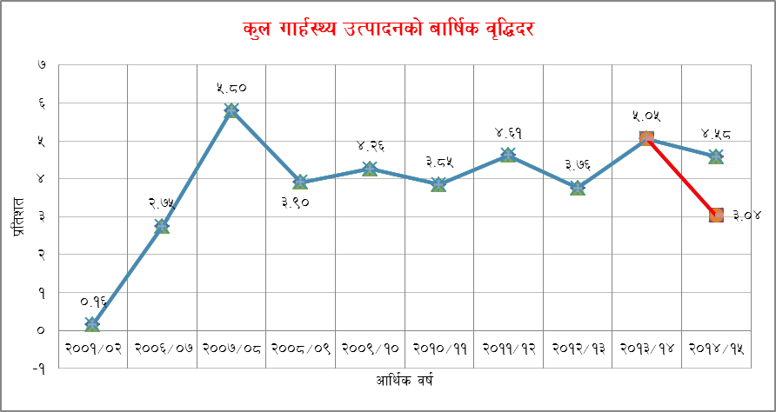@_ rfn" cfly{s jif{ @)&!÷&@ sf] tLgb]lv cf7 dlxgf;Ddsf cfly{s If]qx¿;Fu ;DalGwt cfFs8f tyf ;"rgfx¿sf cfwf/dftof/ ul/Psf] tYofÍ cg';f/ s'n ufx{:Yo pTkfbgsf] a[l4b/ cfwf/e"t d"Nodf (Basic price)$=%* k|ltzt x'g] k|f/lDes cg'dfg /x]sf]dfe"sDkkl5sf] cj:yfdf#=)$ k|ltzt x'g] cg'dfg 5,h'gcfly{s jif{ @)&)÷&!df%=)% k|ltzt /xg]] ;+zf]lwt cg'dfg / cfly{s jif{ @)^(÷&)df#=&^ k|ltzt /xg] clGtd cg'dfg 5 .

**#_ a[xt\ cf}Bf]lus;d"x cg';f/ s'n ufx{:Yo pTkfbg(Gross Domestic product by Broad Industry Group)M**

**#=!_ *k|fylds If]q***

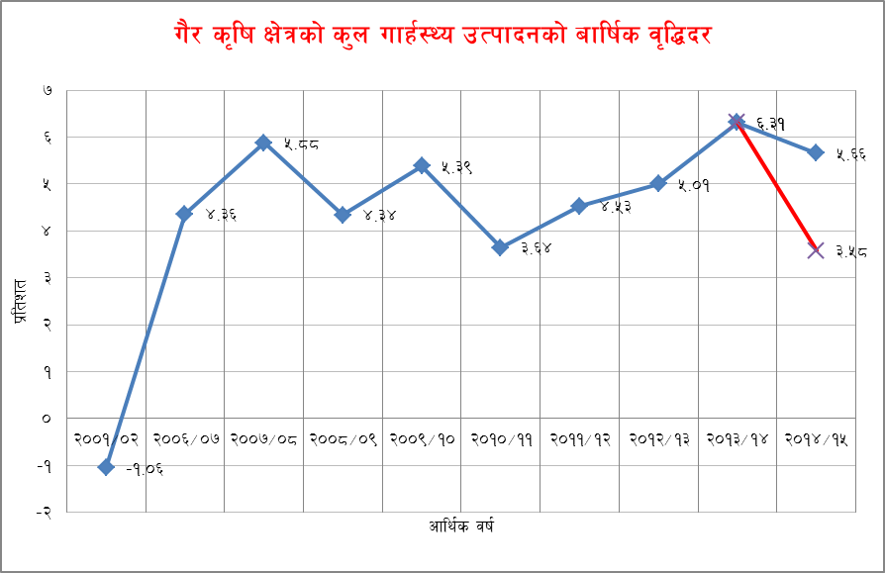o; If]q cGt/ut s[lif tyf jg, dT:o / vfgL tyf pTvgg\ If]q kb{5g\ . cl3Nnf] cfly{s jif{ @)&)÷&! sf] t'ngfdf rfn"cfly{s jif{ @)&!÷&@ df o; If]qsf] ufx{:Yo pTkfbgsf] a[l4b/ @=@&k|ltzt x'g] k|f/lDes cg'dfg /x]sf]df e"sDkkl5sf] cj:yfdf36]/ !=*% k|ltzt x'g] cg'dfg 5.

**#=@_ *låtLos If]q***

o; If]q cGt/ut lgdf{0f,pBf]u / ljB't, Uof; tyf kfgL If]q kb{5g\ . cl3Nnf] cfly{s jif{ @)&)÷&! sf] t'ngfdf rfn"cfly{s jif{ @)&!÷&@ df o; If]qsf] ufx{:Yo pTkfbgsf] a[l4b/ $=%* k|ltzt x'g] k|f/lDes cg'dfg /x]sf]dfe"sDkkl5sf] cj:yfdf36]/ @=^% k|ltzt x'g] cg'dfg 5.

**#=#_ *t[tLos If]q***

o; If]q cGt/ut yf]s tyf v'b|f Jofkf/, xf]6n tyf /]i6'/]G6, oftfoft ;+rf/ tyf e08f/0f, ljQLo dWo:ytf, l/on :6]6 tyf Jofj;flos ;]jf, ;fj{hlgs k|zf;g tyf /Iff, lzIff, :jf:Yo / cGo ;fd'bflos, ;fdflhs tyf JolQmut ;]jf kb{5g\ . cl3Nnf] cfly{s jif{ @)&)÷&! sf] t'ngfdf rfn"cfly{s jif{ @)&!÷&@ df o; If]qsf] ufx{:Yo pTkfbgsf] a[l4b/ %=(*k|ltzt x'g] k|f/lDes cg'dfg /x]sf]dfe"sDkkl5sf] cj:yfdf36]/ #=*^ k|ltzt x'g] cg'dfg 5.

**$_ cf}Bf]lus juL{s/0f cg';f/ s'n ufx{:Yo pTkfbgM**

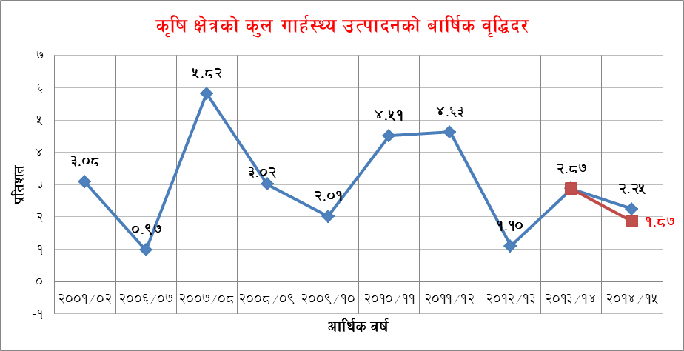 rfn" cfly{s jif{sf] s[lif If]q -s[lif, jg tyf dT:o_ sf] s'n ufx{:Yo pTkfbg@=@% k|ltztn] j[l4 x'g] k|f/lDes cg'dfg /x]sf]df e"sDkkl5sf] cj:yfdf36]/ !=*& k|ltzt x'g] k|f/lDes cg'dfg 5 .u}/ s[lif If]qsf] %=^^ k|ltztn] j[l4 x'g] k|f/lDes cg'dfg /x]sf]df e"sDkkl5sf] cj:yfdf36]/ #=%* k|ltztn] dfq a[l4 x'g] k|f/lDes cg'dfg 5 . cfly{s If]qx¿sf] lj:t[t juL{s/0f cg';f/ jflif{s j[l4b/ lgDgcg';f/ x'g] k|f/lDes cg'dfg ul/Psf]] 5 .

**$=! s[lif tyf jg**

rfn" cf=j=df e"sDkcl3 o; If]qsf] jflif{s a[l4b/ @=!& k|ltzt /xg] k|f/lDes cg'dfg ul/Psf]df e"sDksf] Ifltsf] sf/0f a[l4b/ 36]/ !=&( k|ltzt sfod x'g] cg'dfg ul/Psf] 5 . vf;u/L e"sDkaf6 d[To' ePsf kz'kIfLsf sf/0f b"w tyf df;' pTkfbgdf x'g] x|f; Pj+ e"sDk clt k|efljt lhNnfx¿df cfn', hf} / uxF'sf] pTkfbgdf cfpg] Go"g x|f;sf sf/0f a[l4b/ 36\g] cg'dfg ul/Psf] xf] .

***$=@ dT:okfng***

rfn" cf=j= @)&!÷&@ dfcl3Nnf] cfly{s jif{ @)&)÷&! sf] t'ngfdf o; If]qsf] a[l4b/ ^=#@ k|ltzt /xg] k|f/lDes cg'dfg ul/Psf]df e"sDksf] Ifltsf] sf/0f a[l4b/ ;fdfGo ?kdf 36]/ ^=#! k|ltzt sfod x'g] cg'dfg ul/Psf] 5 . vf;u/L clwstd dT:o pTkfbgx'g] If]qdf -t/fO{df_ e"sDksf] k|efj sd ePsf]n] e"sDkkl5sf] cj:yfdf o;If]qsf] a[l4b/df vf;} km/s gkg]{ cg'dfg ul/Psf] xf] .

***$=# vfgL tyf pTvgg\***

vfgL tyf pTvgg\ If]qdf cl3Nnf] cfly{s jif{ @)&)÷&! sf] t'ngfdf o; jif{sf] s'n ufx{:Yo pTkfbgsf] a[l4b/ $=@* k|ltzt /xg] k|f/lDes cg'dfg ul/Psf]df e"sDkkl5 a[l4b/ 36]/ )=*^ k|ltzt sfod x'g] cg'dfg ul/Psf] 5 . o; If]q cGt/ut vfgL If]qsf] of]ubfg sl/j ^ k|ltzt / pTvgg\ If]qsf] of]ubfg sl/j ($ k|ltzt /x]sf] 5 . vfgL If]qsf] pTkfbgdf e"sDksf] sf/0f vf;} km/s k/]sf] b]lvFb}g . t/ e"sDk clt k|efljt lhNnfx¿df 9'Ëf, lu6L, afn'jf / df6f]sf] pTvgg\df lgs} x|f; cfPsf] 5 eg] kSsL 3/ lgdf{0fdf ;/sf/n] nufPsf] /f]s;Fu} cGo lhNnfx¿df ;d]t 9'Ëf, lu6L, afn'jf / df6f]sf] pTvgg\df x|f; cfPsf] 5 . h;sf sf/0f o;If]qsf] a[l4b/df pNn]Vo x|f; cfpg] cg'dfg ul/Psf] 5 .

***$=$ pBf]u***

pBf]u If]qdf cfly{s jif{ @)&)÷&! sf] t'ngfdf cfly{s jif{ @)&!÷&@ df ufx{:Yo pTkfbgdf $=%% k|ltztn] j[l4 x'g] k|f/lDes cg'dfg ul/Psf]df e"sDkkl5 a[l4b/ @=#% k|ltzt sfod x'g] cg'dfg ul/Psf] 5 . e"sDkkl5 xfn;Dd klg s]xL pBf]u ef}lts Ifltsf] sf/0f ;+rfngdf g} cfpg g;s]sf], ;+rfngdf cfPsf pBf]ux¿df klg sfdbf/sf] cefj, pTkflbt j:t'sf] dfu gePsf] cflb sf/0fn] o;If]qsf] a[l4b/ sd x'g] b]lvG5 .

***$=% ljB't, Uof; tyf kfgL***

o; If]qsf] pTkfbgdf cl3Nnf] cfly{s jif{ @)&)÷&! sf] t'ngfdf o; cfly{s jif{df !=!&k|ltztn] a[l4 x'g] k|f/lDes cg'dfg /x]sfdf e"sDkkl5 a[l4b/ !=!^ k|ltzt sfod x'g] cg'dfg ul/Psf] 5. e"sDkkl5 hnljB't s]Gb|df ef}lts Iflt ePtfklg pTkfbgdf s'g} c;/ gk/]sf], Uof; tyf kfgLsf] pTkfbgdf ;d]t pNn]Vo c;/ gk/]sf]n] o; If]qsf] a[l4b/df vf;} cGt/ gx'g] cg'dfg ul/Psf] 5 .

***$=^ lgdf{0f***

cl3Nnf] cfly{s jif{ @)&)÷&! sf] t'ngfdf rfn" cfly{s jif{df lgdf{0f If]qsf] s'n ufx{:Yo pTkfbg %=*( k|ltztn] a9\g] k"jf{g'dfg ul/Psf]df e"sDkkl5 ut cf=j= sf] t'ngfdf #=%^ k|ltztn] dfq a9\g] cg'dfg ul/Psf] 5 .e"sDkkl5 g]kfn ;/sf/n] ejg lgdf{0fdf /f]s nufPsf] sf/0f lgdf{0f ;dfu|Lsf] cfk"lt{df pNn]vlgo x|f;cfPsf] 5 . ;fy} h:tf kftf jfx]s ;a} lgdf{0f ;fdu|Lsf] pTkfbgdf ;d]t sdL cfPsf] 5 .o;sf/0f ;du|dflgdf{0f If]qsf] ufx{:y pTkfbg e"sDkkl5sf]cj:yfdf36\g uPsf] xf] .

***$=& yf]s tyf v'b|f Jofkf/***

yf]s tyf v'b|f Jofkf/ If]qdf cfly{s jif{ @)&)÷&! sf] t'ngfdf rfn"cfly{s jif{df s'n ufx{:Yo pTkfbgdf %=%( k|ltztn] a[l4x'g] k|f/lDes cg'dfg /x]sf]df e"sDkkl5 #=$# k|ltztn] dfq a[l4 x'g] cg'dfg ul/Psf] 5 . laqmLof]Uo j:t'x¿sf] ;du| pknAwtfnfO{ ljrf/ u/L tof/ ul/Psf] ljj/0fsf] cfwf/df pNn]lvt k"jf{g'dfg ul/Psf] xf] .e"sDkkl5 s[lifIf]qsf] pTkfbgdf cfPsf] x|f;sf] ;fy} Jofkf/of]Uo j:t'sf] cfoftdf ePsf] sdL tyf cf}Bf]lus pTkfbgsf] sdLn] o; If]qsf] d"No clej[l4df cl3Nnf] cfly{s jif{sf] t'ngfdf #=$# k|ltzt dfq a[l4 x'g] b]lvPsf] xf] .

***$=* xf]6n tyf /]i6'/]G6***

xf]6n tyf /]i6'/]G6 If]qdf cl3Nnf] cfly{s jif{sf] t'ngfdf rfn"cfly{s jif{df ^=^) k|ltztn] s'n ufx{:Yo pTkfbgdf a[l4 x'g] k"jf{g'dfg /x]sf]df e"sDkkl5 #=(* k|ltzt dfq a[l4 x'g] cg'dfg ul/Psf] 5 . e"sDkkl5;du| ko{6ssf] cfudgdf ePsf] sdL, xf]6n tyf /]i6'/]G6df ePsf] ef}lts Iflt tyf cfGtl/s ko{6gdf cfPsf] x|f;sf] sf/0f o; If]qsf] pTkfbgdf k"j{cg'dfg ul/Psf] a[l4 xfl;n gx'g]] b]lvG5 .

***$=( oftfoft ;+rf/ tyf e08f/0f***

oftfoft ;+rf/ tyf e08f/0f If]qdf cl3Nnf] jif{ @)&)÷&! sf] t'ngfdf o; cfly{s jif{df &=** k|ltztn] s'n ufx{:Yo pTkfbgsf] a[l4 x'g] k|f/lDes cg'dfg /x]sf]df e"sDkkl5 %=@# k|ltzt dfq a[l4 x'g] cg'dfg ul/Psf] 5 . e"sDkkl5;+rf/ tyf e08f/0f pkIf]qsf]sf/f]af/df vf;} km/s gk/]tf klg:yn oftfoft tyf xjfO{ oftfoftdf ePsf] dGbLsf] sf/0fn] o; If]qdf kl5Nnf] a[l4b/ xfl;n x'g] k"jf{g'dfg ul/Psf] xf] .

***$=!) ljQLo dWo:ytf***

ljQLo dWo:ytfIf]qleq a}+lsª ;d"xdf g]kfn /fi6« a}+s, jfl0fHo a}+s, ljsf;a}+s, ljQ sDkgLx¿sf] ;fy} ;xsf/L ;+:yfx¿sf] sf/f]af/ /x]sf 5g\ . aLdf ;d"xdf aLdf ;ldlt, hLjg aLdf / lghL{jg aLdf sDkgLx¿sf] sf/f]af/x¿ /x]sf 5g\ . To:t} u/L ;fdflhs ;'/Iff of]ubfg ;d"xdf g]kfn lwtf]kq af]8{, sd{rf/L ;+ro sf]if, gful/s nufgL sf]if cflbsf sf/f]af/ /x]sf 5g\ . ;du|?kdf oL pkIf]qdf cl3Nnf] cfly{s jif{ @)&)÷&!sf] t'ngfdf rfn" cfly{s jif{df ljQLo dWo:ytfIf]qdf@=)! k|ltztn] s'n ufx{:Yo pTkfbgdf a[l4 x'g] k"jf{g'dfg /x]sf]dfe"sDkkl5 !=#& k|ltzt dfq a[l4 x'g] cg'dfg ul/Psf] 5 .e"sDkkl5 clt k|efljt If]qdf ko{6g ;]jf, lgdf{0f tyf s[lif If]qdf ePsf] j+}lsË nufgLdf C0faf6 k|fKt x'g] Jofh cfDbfgLdf kg{ ;Sg] c;/sf] ;fy} aLdfÍ bfaLdf ePsf] a9f]Q/LnfO{ cfFsng u/L kl5Nnf] a[l4b/ cg'dfg ul/Psf] 5 .

***$=!! l/on :6]6 tyf Jofj;flos ;]jf***

l/on :6]6 tyf Jofj;flos ;]jf If]q cGtu{t ufx{:Yo pTkfbg a[l4b/ cl3Nnf] jif{sf] t'ngfdf rfn"cfly{s jif{df $=*^ k|ltztn] a9\g] k|f/lDes cg'dfg ul/Psf]df e"sDkkl5 3/ hUufsf] sf/f]jf/ cfPsf] cy{k"0f{ sdL, k"0f{ Iflt ePsf 3/x¿af6 k|fKt x'g] cfjf;Lo ;]jfdf ePsf] s6f}tL tyf Jofj;flos sf/f]jf/df cfPsf] ;fdfGo sdLn] o; If]qdf cl3Nnf] jif{sf] t'ngfdf )=&& k|ltztsf] lemgf] a[l4 x'g] cg'dfg ul/Psf] 5 .

***$=!@ ;fj{hlgs k|zf;g tyf /Iff***

;fj{hlgs k|zf;g tyf /Iff If]qdf rfn" cfly{s jif{ @)&!÷&@ sf] ufx{:Yo pTkfbg a[l4b/ %=&^ k|ltzt x'g] k|f/lDes cg'dfg ul/Psf] 5 . s]Gb|Lo ;/sf/sf] ;fj{hlgs k|zf;g tyf /Iffdf ul/Psf] ah]6 tyf vr{sf] cfwf/df tof/ ul/Psf] cg'dfg cg';f/ o; If]qdf pQm a[l4b/ xfl;n x'g] k"jf{g'dfg 5 . e"sDkkl5 klg ;du|df s]Gb|Lo ;/sf/sf] ;fj{hlgs k|zf;g tyf /Iffdf ul/Psf] ah]6 tyf vr{df vf;} km/s gkg]{ ePsf]n] o; If]qsf] a[l4b/df c;/ gkg]{ b]lvG5 .

***$=!# lzIff***

lzIff If]qdf cl3Nnf] cfly{s jif{sf] t'ngfdf rfn" cfly{s jif{df ^=$&k|ltztn] a[l4 x'g] k"jf{g'dfg ul/Psf]dfe"sDkkl5 $=(& k|ltzt dfq a[l4 x'g] cg'dfg ul/Psf] 5 .lghL tyf u}/;/sf/L If]qx¿af6 ;+rflnt z}lIfs ultljlwx¿df ePsf] kl/jlt{t ;"rssf] cfwf/df tof/ ul/Psf] cg'dfg cg';f/ kl5Nnf] a[l4b/ xfl;n x'g] k|f/lDes cg'dfg ul/Psf] 5 .

***$=!$ :jf:Yo***

:jf:Yo If]qtk{m cfly{s jif{ @)&)÷&! sf] t'ngfdf rfn" cfly{s jif{ @)&!÷&@ df (=*@ k|ltztn] ufx{:Yo pTkfbg a9\g] k|f/lDes cg'dfg ul/Psf]df e"sDkkl5 !)=)$ k|ltzt a[l4 x'g] cg'dfg ul/Psf] 5 . e"sDkkl5 lj/fdL tyf 3fOt]nfO{ pkrf/ ubf{ ;/sf/L If]q,u}/ ;/sf/L tyflghL If]qsf] :jf:Yo ;]jfsf] sf/f]af/df ePsf] a[l4sf] cfwf/df :jf:Yo ;]jf If]qsf] ufx{:Yo pTkfbg a9\g] cg'dfg ul/Psf] xf] .

***$=!% cGo ;fd'bflos, ;fdflhs tyf JolQmut ;]jf***

cGo ;fd'bflos, ;fdflhs tyf JolQmut ;]jf If]qdf ufx{:Yo pTkfbgsf] a[l4b/ cl3Nnf] cfly{s jif{sf] t'ngfdf rfn" cfly{s jif{ @)&!÷&@ df ^=)& k|ltzt x'g] k|f/lDes cg'dfg /x]sf]df e"sDkkl5 %=## k|ltzt a[l4 x'g] cg'dfg ul/Psf] 5 .e"sDkkl5 s]Gb|Lo tyf :yfgLo ;/sf/sf] ;fd'bflos, ;fdflhs If]qdf th{'dful/Psf] ah]6 tyf vr{sf] cfwf/df /lghL If]qx¿af6 ;+rflnt Pkm=Pd= tyf 6]lnlehg h:tf dgf]/~hgfTds ;]jfsf] cfly{s ultljlwx¿sf] cfwf/df o; If]qsf] ufx{:Yo pTkfbg ;+zf]wg x'g] cg'dfg ul/Psf]] 5 .

***%_ e"sDksf]Iflt ljZn]if0f***

b]ze/ rfn" cf=j=df cfwf/e"t d'Nodf #! va{ $^ ca{ a/fj/sf]j:t' tyf ;]jfsf] pTkfbg x'g] cg'dfg ul/Psf]df ljgfzsf/L e"sDkkl5 #) va{ (% ca{ a/fj/sf]j:t' tyf ;]jfsf] pTkfbg x'g] ;+zf]lwt cg'dfg /x]sf] 5 . e"sDksf] sf/0fcfwf/e"t d"Nodf sl/j %! ca{a/fj/sf] j:t' tyf ;]jfsf] pTkfbgdf sdL x'g] cg'dfg ul/Psf] 5 .

o;}u/L rfn" cf=j=df j:t' tyf ;]jfsf] pTkfbgdf pkef]u x'g] j:t' tyf ;]jfsf] jhf/ d"Nodf !! vj{ %^ ca{ a/fj/sf] /sd vr{ x'g] cg'dfg ul/Psf]df ljgfzsf/L e"sDkkl5 !! va{ #^ ca{ a/fj/sf] /sd vr{ x'g] cg'dfg ul/Psf] 5 . e"sDksf] sf/0f jhf/ d"Nodf sl/j @) ca{sf] a/fj/sf] dWojtL{ pkef]udf sdL x'g] cg'dfg ul/Psf] 5 .

b]ze/ rfn" cf=j=df @! va{^!ca{ a/fj/sf]s'n ufx{:Yo pTkfbgx'g] cg'dfg ul/Psf]df ljgfzsf/L e"sDkkl5 @! va{ @% ca{ a/fj/sf]s'n ufx{:Yo pTkfbg x'g] ;+zf]lwt cg'dfg /x]sf] 5 . e"sDksf] sf/0f sl/j #^ ca{ a/fj/sf] s'n ufx{:Yo pTkfbgdf sdL x'g] cg'dfg ul/Psf] 5 .

b]ze/ rfn" cf=j=df k|ltJolQm jflif{s s'n ufx{:Yo pTkfbg ? &&,#!! x'g] cg'dfg ul/Psf]df ljgfzsf/L e"sDkkl5 k|ltJolQm s'n ufx{:Yo pTkfbg ? &$,(*%x'g] kl/dflh{t cg'dfg /x]sf] 5 . e"sDksf] sf/0f k|ltJolQmjflif{ss'n ufx{:Yo pTkfbgdf ? @,#@^n] sdL x'g] cg'dfg ul/Psf] 5 .

rfn" cf=j= )&!.&@ df s'n ufx{:Yo pTkfbgsf] a[l4 b/ cl3Nnf] jif{sf] t'ngfdf $=%* k|ltzt /xg] cg'dfg ul/Psf]df e"sDksf] Ifltsf] sf/0f !=%$ k|ltztn] 36]/ #=)$ k|ltzt sfod x'g] cg'dfg ul/Psf] 5 .

^_ s]Gb|Lo tYof+s ljefun] tof/ ug]{ /fli6«o n]vf ;DaGwL cg'dfgx¿ ;+o'Qm /fi6« ;+3, tYof+s cfof]un] (United Nations, Statistics Commission)l;kmfl/; u/]sf]System of National Accounts, 1993 df pNn]lvt ljlw / juL{s/0fx¿df cfwfl/t 5g\ .

@)&@ ;fn h]7@% ut] ;f]daf/

s]Gb|Lo tYofÍ ljefu, yfkfynL .