cf=j= @)&#÷&$ sf] cf}Bf]lus If]qsf] jflif{s pTkfbgsf] ;"rsf+s
cf=j= @)&#÷&$ sf] ;du| cf}Bf]lus If]q - vfgL tyf pTvgg\; ljB't, UofF; l:6d, jftfg's'lnt j:t'sf] cfk"lt{; / kfgL, kmf]xf]/ ;+sng tyf Joj:yfkg _ sf] jflif{s pTkfbgdf ut cf=j= @)&@÷&# sf] t'ngfdf !@=^@ k|ltztn] a[l4 eO{ ;"rsf+s !)&=(@ c+s k'u]sf] 5 . cfly{s s[ofsnfkx?sf] ;d"xut?kdf x]bf{ vfgL tyf pTvgg\df )=!* k|ltztn] ,pBf]udf !&=!! k|ltztn], ljB't tyf UofF;df @!=%( k|ltztn] / kfgLdf !=!* k|ltztn] pTkfbgdf a[l4 ePsf] b]lvG5 . o;/L ;du| ;"rsf+sdf a[l4 x'g'sf] sf/0f pBf]ux?df lgoldt ljB't cfk"lt{ x'g' , aGb tyf x8\tfndf sld x'g', e"sDk kl5 k"0f{ ?kdf ;+rfngdf cfpg g;s]sf pBf]ux? qmdz k"0f{ ?kdf ;+rfngdf cfpg' cflbnfO{ lng ;lsG5 .

jflif{s cf}Bf]lus If]qsf] pTkfbgsf] ;"rsf+ssf] l:yltM
pTkfbgsf] ;"rsf+sx? | cf=j= @)&@÷)&# -jflif{s_ | cf=j= @)&#÷)&$ -jflif{s_
s'n ;"rsf+s (IIP) | 95.83 | 107.92
vfgL tyf pTvgg\ | 105.24 | 105.44
pBf]u (MPI) | 90.21 | 105.64
ljB't / UofF; | 91.82 | 111.65
kfgL | 106.91 | 108.17

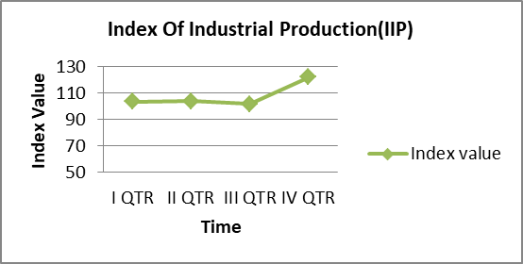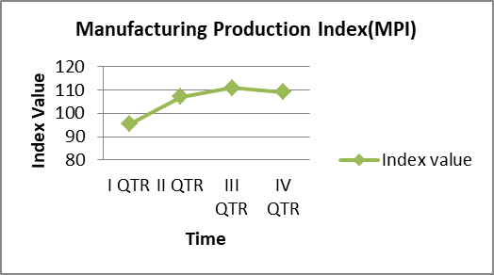

pBf]u If]qsf] jflif{s pTkfbgsf] ;"rsf+s (Manufacturing Production Index) sf] l:yltM
pBf]u If]qsf] pTkfbgsf] ;"rsf+s NSIC 3 - Digit cg';f/ 5flgPsf @( j6f j:t'ut ;d'xx? dWo] cf=j= @)&@÷&# sf] ;"rsf+s;+u cf=j= @)&#÷&$ sf] ;"rsf+snfO{ t'ngf ubf{ !^ j6f ;d"xx?df !) k|ltzt eGbf a9L a[l4 ePsf] b]lvG5 . h; cg';f/ clwstd a[l4 x'g]df kz'bfgf ;d"xdf %$=&^ k|ltzt /x]sf] 5 . To;} u/L % j6f NSIC ;d"xx?df !) k|ltzt eGbf sd j[l4 ePsf] b]lvG5 eg] afFsL * j6f ;d"xx?sf] pTkfbgdf lu/fj6 cfPsf] b]lvG5 . clwstd lu/fj6 x'g]df Knfli6ssf] pTkfbg ;d"xdf !#=$* k|ltzt /x]sf] 5 .
j:t'ut cfwf/df cf=j= @)&@÷&# / o; cfly{s jif{sf] jflif{s pTkfbgsf] ;"rsf+sx?sf] t'ngf ubf{ ## j6f 4-Digit CPC j:t'x?sf] pTkfbgdf !) k|ltzt eGbf al9 ,( j6f j:t'sf] pTkfbgdf !) k|ltzt eGbf sd a[l4 ePsf] b]lvG5 . To;} u/L # j6f j:t'x?sf] pTkfbgdf % k|ltzt eGbf sd / ( j6f j:t'x?sf] pTkfbgdf % k|ltzt eGbf al9 lu/fj6 ePsf] b]lvG5 . clwstd a[l4 x'g]df l:6nsf] 6\o"a / kfO{ksf] pTkfbgdf *)=!@ k|ltzt /x]sf] 5 eg] clwstd lu/fj6 x'g]df lrgLsf] pTkfbgdf @&=(! k|ltzt /x]sf] 5 . o;/L lrgLsf] pTkfbg 36\g'df lrgL pTkfbgsf]nflu cfjZos sRrf kbfy{sf] cefj /x]sf] b]lvG5 .

