cf=j= @)&$÷&% sf] cf}Bf]lus If]qsf] jflif{s pTkfbgsf] ;"rsf+s
cf=j= @)&$÷&% sf] ;du| cf}Bf]lus If]q - vfgL tyf pTvgg\; ljB't, UofF; l:6d, jftfg's'lnt j:t'sf] cfk"lt{; / kfgL, kmf]xf]/ ;+sng tyf Joj:yfkg _ sf] jflif{s pTkfbgdf ut cf=j= @)&#÷&$ sf] t'ngfdf (=(& k|ltztn] a[l4 eO{ ;"rsf+s !!^=* c+s k'u]sf] 5 . cfly{s s[ofsnfkx?sf] ;d"xut?kdf x]bf{ vfgL tyf pTvgg\df !!=$% k|ltztn] ,pBf]udf (=(^ k|ltztn], ljB't tyf UofF;df (=%^ k|ltztn] / kfgLdf (=&) k|ltztn] pTkfbgdf a[l4 ePsf] b]lvG5 . o;/L ;du| ;"rsf+sdf a[l4 x'g'sf] sf/0f /fhgLlts l:y/tf , pBf]ux?df lgoldt ljB't cfk"lt{ x'g' , aGb tyf x8\tfndf sld x'g', e"sDk kl5 k"0f{ ?kdf ;+rfngdf cfpg g;s]sf pBf]ux? qmdz k"0f{ ?kdf ;+rfngdf cfpg' tyf cf}Bf]lus a:t'x?sf] pTkfbgsf] nflu cg's"'n jftfa/0f x'g' cflbnfO{ lng ;lsG5 .

jflif{s cf}Bf]lus If]qsf] pTkfbgsf] ;"rsf+ssf] l:yltM
pTkfbgsf] ;"rsf+sx? | cf=j= @)&#÷)&$ -jflif{s_ | cf=j= @)&$÷)&% -jflif{s_
s'n ;"rsf+s (IIP) | 106.10 | 116.8
vfgL tyf pTvgg\ | 105.28 | 117.33
pBf]u (MPI) | 105.64 | 116.17
ljB't / UofF; | 110.69 | 121.27
kfgL | 108.17 | 118.65

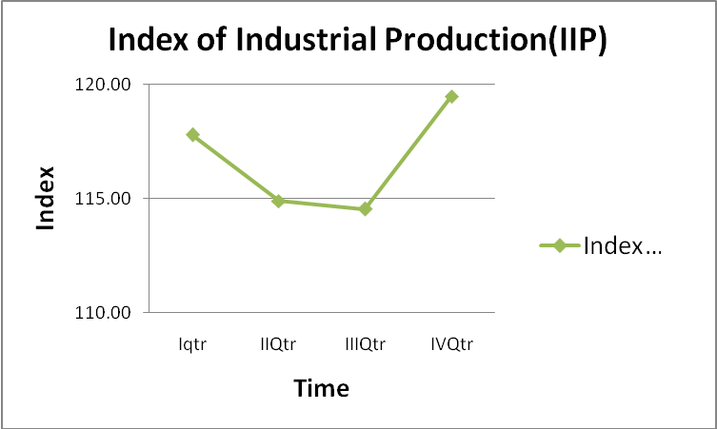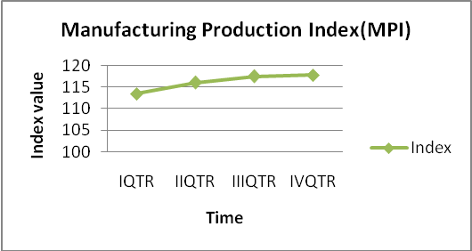

pBf]u If]qsf] jflif{s pTkfbgsf] ;"rsf+s (Manufacturing Production Index) sf] l:yltM
pBf]u If]qsf] pTkfbgsf] ;"rsf+s NSIC 3 - Digit cg';f/ 5flgPsf @( j6f j:t'ut ;d'xx? dWo] cf=j= @)&#÷&$ sf] ;"rsf+s;+u cf=j= @)&$÷&% sf] ;"rsf+snfO{ t'ngf ubf{ @% j6f ;d"xx?sf] pTkfbgdf a[l4 ePsf] b]lvG5 eg] afFsL $ j6f ;d"xx?sf] pTkfbgdf lu/fj6 cfPsf] b]lvG5 . a[l4 ePsf @% j6f ;d"xx? dWo] !$ j6f ;d"xx?sf] pTkfbgdf !) k|ltzt eGbf a9L a[l4 ePsf] b]lvG5 . h; cg';f/ clwstd a[l4 x'g]df k|;f]lwt k]6«f]lnod j:t' pTkfbg ;d"xdf #^=&% k|ltzt /x]sf] 5 . To;} u/L !! j6f ;d"xx?sf] pTkfbgdf !) k|ltzt eGbf sd j[l4 ePsf] b]lvG5 . h; cg';f/ ;a}eGbf sd a[l4 x'g]df wft'sf ljleGg 9fFrfdf ag]sf ;+/rgfx¿ h:t}M 6\ofÍ, l/hEof{P/, l:6d h]g]/]6/ h:tf j:t'x¿sf] pTkfbg ;d"xdf )=^ k|ltzt /x]sf] 5 . csf]{tkm{ clwstd lu/fj6 x'g]df sfTg], a'Gg], sk8fnfO{ lkmlgl;ª ug]{ lqmofsnfkdf ^=(% k|ltzt /x]sf] 5 .
j:t'ut cfwf/df cf=j= @)&#÷&$ / o; cfly{s jif{sf] jflif{s pTkfbgsf] ;"rsf+sx?sf] t'ngf ubf{ 5flgPsf %$ j6f j:t'x? dWo] @% j6f 4-Digit CPC j:t'x?sf] pTkfbgdf !) k|ltzt eGbf al9 ,!) j6f j:t'sf] pTkfbgdf !) k|ltzt eGbf sd a[l4 ePsf] b]lvG5 . To;} u/L * j6f j:t'x?sf] pTkfbgdf % k|ltzt eGbf sd / % j6f j:t'x?sf] pTkfbgdf ;fdfGo a[l4 ePsf] b]lvG5 eg] ^ j6f j:t'x?sf] pTkfbgdf lu/fj6 ePsf] b]lvG5 . clwstd a[l4 x'g]df k|;f]lwt k]6«f]lnod j:t'x? -df]lan ,lu|h cflb_ sf] pTkfbgdf #^=&% k|ltzt /x]sf] 5 eg] clwstd lu/fj6 x'g]df kf]ln:6/ ofg{sf] pTkfbgdf !#=%% k|ltzt /x]sf] 5 .

