- HOSPITAL SERVICES OR MAJOR AVILABLE SERVICES:
- OPD (OUT PATIENT DEPARTMENT) SERVICE.
- INDOOR SERVICE
- EMERGENCY SERVICE
- LABORATORY SERVICE
- Radiology Service (ULTRASOUND , DIGITAL X- RAY , ECG)
- DELIVERY SERVICE /CAESEREAN SECTION
- SAFE ABORTION SERVICE
- PHARMACY SERVICE
- DENTAL SERVICE
- DOTS SERVICE
- RABBIS VACCINE SERVICE
- HEALTH INSURANCE PROGRAMME
- SOCIAL SERVICE UNIT
- OCMC SERVICE
- NUTRATION REHABILITATION CENTER
- MEDICOLEGAL SERVICE
- FAMILY PLANNING SERVICE
- SSU SERVICE
- NRC SERVICE

  - alx/Ë ;]jf (OPD Service)
o; c:ktfndf aflx/Ë ;]jf (OPD service) laxfg !) ah] b]lv b}lgs ?kdf ;+~rfng x'G5 . lhNnf c:ktfn vf]6fª af6 b}lgs ;+~rfng x'g] cf]=lk=8L=df h]g]/n d]l8l;gsf la/fdL w]/} x'g] ub{5g\ . o; c:ktfndf cfO{taf/ / z's|af/ cf]=lk=8L=df la/fdLx?sf] rfk w]/} x'g] ub{5 . ;fdfGotof aflx/Ë ;]jfdf cf};t %) hgf la/fdLx?n] ;]jf kfO{/x]sf] b]lvG5 . o; c:ktfndf /fli6«o jLdf sfo{s|d nfu" ePsfn] b}lgsh;f] $) b]lv %) hgf jLldt la/fdLx?n] ;]jf kfO /x]sf] kfOG5 . cf]=lk=8L df la/fdL tyf 8fS6/x?sf] nflu xfn;Dd kof{Kt sf]7f gePsf] tyf cktfnsf eag lgdf0f{ ;DkGg ePsf] sf/0f k'/fgf] ejgsf] ;+/rgf tyf k|ofKt sf]7fsf] cefasf] sf/0f ;]jf k|afx ug{ sl7gfO{ /x]sf] 5 . o; cf=a)*!.)*@ df :jf:Yo hfFr ug{ cfPsf lj/fdL ;+Vof &%&& hgf 5g\ .

  - cGt/Ë ;]jf (Idoor Service)

aflx/ ;]jf ;+rfng c:yfoL ?kdf ag]sf] ! tn] lk|km]jsf] eagaf6 cGt/Ë ;]jf (Indoor Service_ ;+rflnt 5 . cGt/Ë ;]jf lbgsf] nflu o; c:ktfndf !) a]8sf] :jLs[t ePtf klg !) cf]6f la/fdL a]8 ;+~rfngdf /x]sf] 5 . c:ktfnsf] b/aGbL cg';f/sf] sd{rf/L kbk'lt{ gePtf klg 5fqa[l4 s/f/,k|b]z :jo+;]js,;ldlt s/f/ tyf sfo{qmd s/f/ dfkm{t sd{rf/L egf{ ul/ ;]jf k|afx ul/ /x]sf] 5f} . cfjZostf cg';f/ ;]jf k|afx ug{ ef}uf]lns ?kdf eagsf sf]7fx? kof{Kt gePtf klg la/fdLx?nfO{ ;]jf k|bfg ug]{ pb]Zon] a]8x? 5'6\ofO ;+~rfngdf NofOPsf] 5 . cGt/Ë ;]jf cGtu{t k|;'lt ;]jf ,;'/lIft ue{ktg ;]jf, SNCU ;]jf, h:tf ;]jfx? /x]sf 5g\ . o; cf=a df cGt/Ë ljefudf ^#) hgf egf{ ePsf] lyof] .
  - cfsl:ds ;]jf (EMERGENCY Service)
cfsl:ds ;]jf c:ktfnsf] clt dxTjk"0f{ ;]jf xf] . o; c:ktfndf cfsl:ds pkrf/ ;]jf cnUu} c:yfoL ?kdf l6gsf] h:tf k|of]u u/L agfO{Psf] ejgaf6 % hgf la/fdLnfO{ pkrf/ ug{ ;Sg] u/L ;+rflnt 5 . ejg w]/} klxn] lgdf{0f eO{ ;+rfngdf cfPsfn] xfnnfO{ la/fdLsf] rfk a9]sfn] cln ;fu'/f] /x]sf] lyof] . o; zfvfdf ;]jf lbgsf] nflu Kof;]G6 df]lg6/, O=;L=hL= d]l;g ,:6«]r/ cflb laleGg cf}hf/ pks/0f, Odh{ ]G;L cf}iflwsf] Joj:yfkg ul/Psf] 5 . Od/h]G;L zfvfdf TRIAGE sf] Joj:yf /x]sf] 5 ;fy} o; zfvfdf ;fO/g klg h8fg ul/Psf] 5 . sd{rf/L ;dfof]hg k|s[ofn] ubf{ b/aGbL cg';f/ sd{rf/L gePklg c:ktfn lasf; ;ldlt nufot cGo ;|f]taf6 s]xL hgzlQm s/f/ ;]jfdf lnO{ la/fdLnfO{ cfjZos cfs:dLs ;]jf pknAw u/fO{+ b} cfPsf] 5 . o; cf a df Od{h]G;L zfvfdf cfPs hDdf la/fdL ;+Vof ^&^# dWo] ##*# hgf dlxnf / ##*) k'?if /x]sf 5g\ .

प्रयोगशाला सेवा (LABORATORY Service)
    - k|of]uzfnf zfvf klg c:ktfnsf] OPD ;+rfng /x]sf] ejgdf ;+~rflnt 5 . o; zfvfaf6 @$ 306f ;]jf k|bfg ul/G5 . la/fdLnfO{ l56f] 5l/tf] / u'0f:t/Lo ;]jf pknAw u/fpg o; cf=j=df klg yk c6f]d]6]8 PgnfOh/ d]l;gx? h8fg ul/Psf 5g\ . o; zfvfdf la/fdLx?n] lgoldt ug'{ kg]{ hfFrsf cltl/Qm laleGg k|of]uzfnf ;]jfx? kfO/x]sf 5g\ . o; cf=a df #@$$ hgfn] k|of]uzfnf zfvfaf6 ;]jf lnO nfeflGjt ePsf 5g\ o; zfvf cGt{ut lbO{g] ;]jfx?df M

    - l;=la=l;=
    - ;'u/ kl/If0f
    - sf]n]:6«f]n kl/If0f
    - lk=l6=cfO{=Pg=cf/ kl/If0f
    - le6fldg–l8 kl/If0f
    - Pr= cfO{=eL kl/If0f
    - lhg PS;kf]6{ ;]jf
    - cf/=Pkm=6L,Pn=Pkm=6L=
    - yfO/f]O8 kl/If0f
    - lnlk8 k|f]kmfOn cflb nufot ;]jfx? kfO{G5 .

  - /]l8of]nf]hL ;]jf (RADIOLOGY Service)
/]l8of]nf]hL ;]jf o; c:ktfndf @$ 306f ;+~rfngdf /xG5 . /]l8of]nf]hL ;]jf cGtu{t laleGg ;]jfx? lbb} cfO/x]sf] 5 . /]l8of]nf]hL ;]jfcGtu{t lgDg ;]jfx? pknAw 5g\ . o; cf=j df k|b]z ;/sf/ dfkm{t ! j6f cN6«f;fp08 d]l;g pknAw ePsf] 5 .
- USG
- X-Ray
- ECG

o; ;]jf cGtu{t b}lgs ?kdf ;]jf lng] la/fdLx? cf}iftdf sl/a $ hgfn] ;]jf pkef]u ug{ kfO /x]sf 5g\ . o; c:ktfndf cfPsf la/fdL dWo] o; cfly{s jif{df $@@ hgfn] PS;/] ;]jf, #@! hgfn] o' P; hL ;]jf / #&( hgfn] Ol;hL ;]jf lng kfPsf छन् .

  - bGt ;]jf (Dental service)
o; c:ktfndf bGt ;]jf b}lgs cf]=lk=8L ;dodf ;+~rfng x'G5 . 8]G6n ;]jf cGtu{t tkl;n cg';f/sf laleGg ;]jfx? k|bfg ul/G5 . o; cfly{s jif{df cf]=lk=8L cfPsf la/fdL dWo] #)) hgfn] ;]jf pkef]u ug{ kfPsf 5g\ .

    - 8]G6n PS; /] ;]jf
    - :s]nLª ;]jf
    - cf/=l;=l6=;]jf
  - :af:Yo aLdf sfof{qmd

;+ljwfgdf df}lnsxssf] ?kdf Aoj:yf eP cg'?k hgtfn] :jf:Yo ;]jf k|fKt ug{] clwsf/nfO{ sfof{Gjogdf NofO{ hgtfnfO{ ;j{;'ne ,u'0ff:t/Lo / ;:tf] d"Nodf :jf:Yo ;]jf k|bfg ug]{ tyf cfwf/e"t :jf:Yo ;]jfdf ;a}sf] kx'r a9fpg] p2]Zon] g]kfn ;/sf/n] :jf:Yo aLdf sfo{s|d @)&^ ;fnaf6 o; c:ktfndf ;+rfng ul/Psf] xf] .

  - kf]if0f k'g{:yfkgf u[x

u|fld0f tyf ljkGg ju{sf g]kfnLsf] kl/j]zdf s'kf]if0f ePsf afnaflnsfx? nfO{ c:ktfndf Nofpg] aflg gePsf]n] h'gh'g a]nf afnaflnsfx?nfO{ cGo /f]un] u|:t kf5{ To;k5L dfq c:ktfn NofOg] ul/G5 . c:ktfndf aRrfnfO{ nfu]sf] tfTsflns /f]usf] dfq pkrf/ ul/G5 . ;do / a] 8sf] cefjdf aRrfsf] s'kf]if0f k|lt Tolt Wofg k'Ug ;ls/x]sf] 5}g . c:ktfndf pkrf/ kZrft\ l8:rfh{ eP/ uPsf afnaflnsfx?nfO{ k'/fg} /f]un] km]/L ;tfpg] jf gofF /f]un] ;dfTg] 8/ w]/} x'G5 . o:tf] cj:yfdf jRRffdf af}¢Ls tyf zf/L/Ls ckf‹tfsf] l;sf/ x'g] tyf u+eL/ s8f /f]u nfUg] -s8f s'kf]if0f_ / Hofg} hfg] hf]lvd klg ;S5 . o:tf s'kf]if0fn] u|:t ePsf afnaflnsfx?nfO{ plrt vfgkfgsf ;fy} plrt :ofxf/ ;';f/sf] Aoa:yf ;lxtsf] cfjfl;o kf]if0f k'g{:yfkgf u[xsf] cfjZostf kb{5 . g]kfn ;/sf/n] afnaflnsfx?sf nflu kf]if0fo"Qm cfxf/ tyf plrt :jf:Yof]krf/n] ;'lawf ;DkGg kf]if0f u[xsf] cfaZostf 68\sf/f] ?kn] b]v]sf] x'gfn] of] ;d:ofsf] ;dfwfgsfnflu bft[ ;+:yfx?;+usf] ;xsfo{df kf]if0f k'g{:yfkgfu[xsf] kl/sNkgf cufl8 ;f/]sf] xf] .

cf=j= @)*)÷*! df o; c:ktfndf /x]sf] kf]if0f k'g{:yfkgf u[xdf egf{ ePsf @! hgf s'kf]lift afnaflnsfx? dWo] !( hgf k'0f{ ?kdf ;'wf/ eO{ l8:rfh{ ePsf 5g\ eg] @ hgf nfO{ yk pkrf/sf nflu cGo c:ktfndf k|]if0f ul/Psf] 5 o:t} o; cf=a @)*!.*@ df egf{ ePsf !) hgf la/fdL dWo] ( hgf k'0f{ ?kdf ;'wf/ eO{ l8:rfh{ ePsf 5g\ eg] ! hgfnfO{ yk pkrf/sf nflu cGo c:ktfndf k|]if0f ul/Psf] 5 .

  - Ps4f/ ;+s6 Joj:yfkg s]Gb

n}lªs lx+;f kLl8t ÷k|efljtx? ljz]if u/L aflnsf, lszf]/L, n}lËs tyf of}lgs cNk;+Vos dlxnfx?nfO{ ax'kIfLo ;+of]hg4f/f PsLs[t?kdf :jf:Yo ;]jf, dgf];fdfhLs k/fdz{, lrlsT;fhGo k|df0f ;+sng / ;+/If0f cNksfnLg cf>o sfg'gL pkrf/ ;'/Iff tyf ;+/If0f kl/jf/ jf ;d'bfodf k'g:yf{kgf hLljsf]kfh{gdf ;xof]u ;fdfhLs k'gldng ;lxtsf] dof{lbt h:jgofkg u/fpg] p2]Zon] tf]lsPsf c:ktfnx?df Ps4f/ ;+s6 Joj:yfkg s]Gb| :yfkgf u/L ;+rfngdf NofOPsf] xf] . ;f]xL cg';f/ o; c:ktfndf /x]sf] Ps4f/ ;+s6 Joj:yfkg s]Gb| af6 cf=a=)*).)*! df #$ hgf dlxnfnfO{ 5 eg] cf=a=@)*!.@)*@ df $ hgf dlxnf dWo] zf/Ll/s lx+;f df % hgf, afnlaafx @ hgf, of}g b'Jo{jxf/ !@ hgf / anTsf/sf @% hgf dlxnfn] o; s]Gb| af6 ;]jf lnPsf 5g\ .

  - ;fdflhs ;]jf PsfO{ sfo{s|d

g]kfnsf] ;+ljwfg @)&@ sf] wf/f #% df æk|To]s gful/snfO{ /fHoaf6 sfg"gdf Joj:yf eP adf]lhd cfwf/e"t :jf:Yo ;]jf lgMz'Ns k|fKt ug]{ xs x'g]5 / s;}nfO{ klg cfsl:ds :jf:Yo ;]jfaf6 jl~rt ul/g] 5}gÆ egL :jf:Yo ;]jfnfO{ g]kfnL gful/ssf] df}lns xs cGtu{t /fv]sf] 5 . ;/sf/n] ;+ljwfgsf] efjgf ;d]tnfO{ b[li6ut u/L lgMz'Ns /fli6«o :jf:Yo ;]jf sfo{qmd nfu" u/]sf] 5 . ;f] sfo{qmdcGtu{t @)*) kf}if af6 df3b]lv @% z}of;Ddsf c:ktfnx¿df

cfd–gful/snfO{ ;"rLs[t cTofjZos cf}ifwL lgMz'Ns ¿kdf k|bfg ug{ ;'? u/]sf] 5 . ;fy} nlIft ;d"xsf la/fdLx¿nfO{ cTofjZos cf}ifwL ;fy} cGt/Ë, alx/Ë / cfsl:ds ;]jf lgMz'Ns pknAw u/fpg] ul/Psf] 5 . c:ktfnx¿df dGqfnon] ;zt{ / lgMz'Ns cf}ifwLsf nflu (Conditional and Medicine Grants) cg'bfg /sd pknAw u/fO{ ;f] /sdaf6 nlIft ;d"xsf la/fdLx¿nfO{ lgMz'Ns jf cf+lzs 5'6df :jf:Yo ;]jf pknAw u/fpg' kg]{ k|fjwfg cg';f/ c:ktfnx¿n] ;]jf pknAw u/fpFb} cfPsf 5g\ . s]Gb|Lo, If]qLo, pk–If]qLo, c~rn c:ktfn, ;fd'bflos tyf lzIf0f c:ktfnx¿df nlIft ;d"xsf la/fdLx¿nfO{ pknAw u/fpFb} cfPsf] ;x'lnot :jf:Yo ;]jfnfO{ Jojl:yt, kf/bzL{ / k|efjsf/L agfpg] p2]Zon] cf=j= @)^(÷&) b]lv * j6f c:ktfnx¿df ;fdflhs ;]jf PsfOsf] :yfkgf eO{ qmlds ¿kdf lj:tf/ ub}{ cf=j=@)&&÷&* ;Dddf $$ j6f c:ktfnx¿df ;]jf ;~rfng ul/Psf] 5 . lhNnf c:ktfn vf]6fªdf cf=j= @)&(÷*) af6 of] sfo{s|d ;'? ePsf] xf] . cf=j= @)*)÷*! df o; sfo{s|d cGt/ut laleGg nlIft ;d"xsf !^( dlxnf / @(@ k'?if u/L hDdf $^! hgfnfO{ ;]jf k|bfg ul/Psf] 5 . o; sfo{s|daf6 ;]jf kfpg] nlIft ;d"x lgDg cg';f/ 5g\ .o:t} cf=a=@)*!.*@ df @^! hgf dWo] $^ hgf dlxnf / @!% hgf k'?if /x]sf 5g\ .

nlIft ;d"xx?
-!_ u/La
-@_ c;xfo
-#_ ckfªtf ePsf AolQm
-$_h]i7 gful/s
-%_ n}lªs lx+;f kLl8t -afnaflnsf ;d]t_
-^_ dlxnf :jf:Yo :jo+;]ljsf -kl/rokq afxs_
-&_ k|fs[lts k|sf]k -e"sDk,af9L,klx/f],cfunfuL cflb_af6 kLl8t
-*_ zlxb kl/jf/ -k/Lrokq afxs_
-(_ s'kf]lift afnaflnsf
-!)_ k|x/Ln] NofPsf y'g'jf
-!!_ b'3{6gfdf k/]sf la/fdL -cleefjs gePsf]_
-!@_ ;LdfGts[t tyf nf]kf]Gd'v cflbaf;L hg

- HOSPITAL BED:
Description | Total
Sanctioned Beds (Government) | 15
Sanctioned Beds (Development committee) | 0
Total operational Beds | 15
Total inpatient beds | 10
NICU beds | 0
Emergency Department | 1
Geriatric | 0
Other(Cabin) Maternal Bed | 3

- HUMAN RESOURCE
  - Civil Service

Post | GOVERNMENT |  | CURRENT ABAILABLE
Post | Sanctioned post  (In number) | Fulfilled  (In number) | Among Government Sanction  ( In Number) | Local & other resources ( In Number)
CONSULTANT | 1 |  |  | 1
MEDICAL OFFICER | 2 | 3 | 3  (1-Kaj,Study Leave - 1) | 6
DENTAL SURGEON |  |  |  | 1
NURSING OFFICER |  |  |  | 1
MEDICAL LAB TECHNOLOGIST |  |  |  | 1
Radiographar | 1 |  |  | 0
Dark Room Assistant | 1 | 1 | 1
Staff Nurse | 4 | 4 | 4 | 3
Lab Technician | 1 | 1 | 1
Health Assistant | 1 | 1 | 1 | 1
Anesthesia Assistant | 1 |  |  | 1
Pharmacy Assistant |  |  |  | 0
Biomedical Technician |  |  |  | 0
ANM | 2 | 2 | 2 | 8
AHW | 2 | 0 | 0 | 5
Lab Assistant | 1 | 1 | 1 | 1
Medical Recorder | 1 | 0 | 0 | 0
Haluka Sawari Chalak | 1 | 0 | 0 | 0
Supporting Staff/Sweeper | 11 | 2 | 2 | 17
- c:ktfn Aoj:yfkg ;ldltsf ;b:ox?sf] gfdfanL
l;=g+= | gfd | kb | ;Dks{ g+=
!= | >L 6]s/ffh e§/fO{ -lhNnf ;dGjo k|d'v_ | cWoIf
@= | >L t]h]Gb| vgfn - gu/kflnsf k|d'v_ | ;b:o
#= | >L d]v axfb'/ duf|tL -k|d'v lhNnf clwsf/L_ | ;b:o
$= | >L dbg s]=;L= -lhNnf k|x/L k|d'v_ | ;b:o
%= | >L dlgiff df]Qmfg -:jf:Yo sfof{no k|d'v_ | ;b:o
^= | >L 1fg]Gb df:s] -pBf]u jfl0fHo ;+3 cWoIf_ | ;b:o
&= | >L gf/fo0f k|;fb bfxfn -g]kfn /]8s|; ;f];fO6L ;efklt_ | ;b:o
*= | >L k]|d/fh u'?ª -dgf]lgt_ | ;b:o
(= | >L /f]lxt u'?ª -dgf]lgt_ | ;b:o
!)= | >L k|sfz s6'jfn -dgf]lgt_ | ;b:o
!!= | >L OR5fs'df/L u'?ª -dgf]lgt_ | ;b:o
!@= | >L 8f= /lj s'df/ ofbj -lgldQ d]l8sn ;'k/L6]08]06_ | ;b:o ;lrj

- c:ktfnsf] ef}lts ;DktL sf] ljj/0f
अपतालको नाममा भएको जगाको क्षेत्रफलः १२ रोपनि अपतालको जगा धनी प्रमाणापूजा अनुसार नाम र ठेगानाः जिल्ला अस्पताल ओखलढुंगा कि.नं. : १
- FINANCIAL RESOURCE
  - Hospital Development Committee

आ.व.२०८१/८२ मा अपताल विकास समिति तर्फको आय व्यय विवरण

वार्षिक आदानी |  |  | वार्षिक खर्च
सि.न. | शिर्षक | जम्मा आम्दनी | सि.न. | शिर्षक | जम्मा आम्दनी | कैफियत
१ |  |  | १

- Hospital Services
Hospital reporting status
The DHIS Reporting status is 100% in fiscal year 2080/081.

  - Bed occupancy rate (in %)

The bed occupancy rate is 59.19% in fiscal year 2081/082 .

  - Average length of stay

The average length of stay in fiscal year 2081/082 is 3 days.

- Hospital use
  - Emergency

One thousand Two Hundred Twenty six patients are treated in Emergency department in fiscal year 2081/82.

  - OPD

Total 7577 New & Folloup patient visited in OPD in fiscal year 2081/82 . OPD visit .

  - Inpatients

- Top Ten Morbidity FY 2081/82
  - Outpatients Top Ten Morbidity
SN | Diseases | Female | Male
1 | Gastritis (APD) | 1371 | 759
2 | Upper Respiratory Tract Infection (URTI) Cases | 1068 | 843
3 | Cardiovascular & Respiratory Related Problems-Hypertension | 525 | 492
4 | OPD Morbidity-Common Symptoms-Fever | 481 | 503
5 | Oral Health Related Problems-Dental Caries Cases | 473 | 257
6 | ENT Infection-Pharyngitis/Sore Throat Cases | 395 | 223
7 | Other Infected Diseases-Urinary Tract Infection (UTI) Cases | 289 | 170
8 | Outpatient Morbidity-ENT Infection-Acute Tonsilitis Cases | 274 | 220
9 | Cardiovascular & Respiratory Related Problems-COPD | 231 | 177
10 | Other Diseases & Injuries-Dog Bite | 174 | 209

  - Inpatient morbidity by age and sex, all hospitals,2081/82
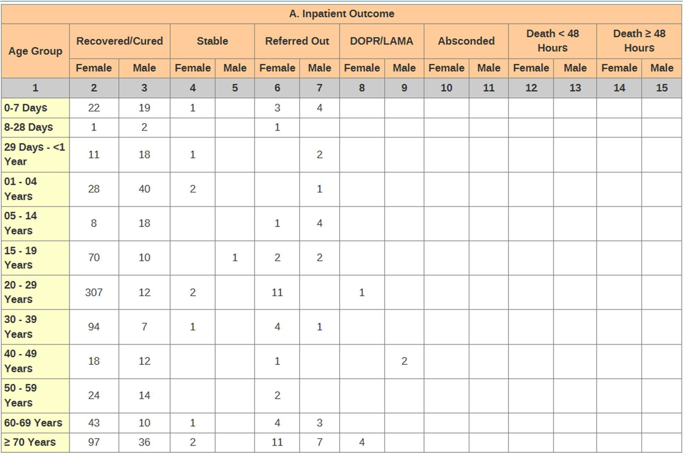

Top Ten Morbidity FY 2081/82
  - Outpatients Top Ten Morbidity
SN | Diseases | Female | Male
1 | Gastritis (APD) | 1371 | 759
2 | Upper Respiratory Tract Infection (URTI) Cases | 1068 | 843
3 | Cardiovascular & Respiratory Related Problems-Hypertension | 525 | 492
4 | OPD Morbidity-Common Symptoms-Fever | 481 | 503
5 | Oral Health Related Problems-Dental Caries Cases | 473 | 257
6 | ENT Infection-Pharyngitis/Sore Throat Cases | 395 | 223
7 | Other Infected Diseases-Urinary Tract Infection (UTI) Cases | 289 | 170
8 | Outpatient Morbidity-ENT Infection-Acute Tonsilitis Cases | 274 | 220
9 | Cardiovascular & Respiratory Related Problems-COPD | 231 | 177
10 | Other Diseases & Injuries-Dog Bite | 174 | 209

  - Hospital Death and post-mortem cases
 | 2079/80 | 2080/81 | 2081/82
Neonatal Death | 0 | 0 | 0
Maternal Deasth | 0 | 0 | 0
Hospital Death in Emergency | 0 | 0 | 0
Brought dead | 0 | 0 | 3
Post-mortem done | 86 | 61 | 68
Number of patient brought dead are Threer and Fiftynine autopsy performed in fiscal year 2080/81.

  - Social Security Programme FY:081/082

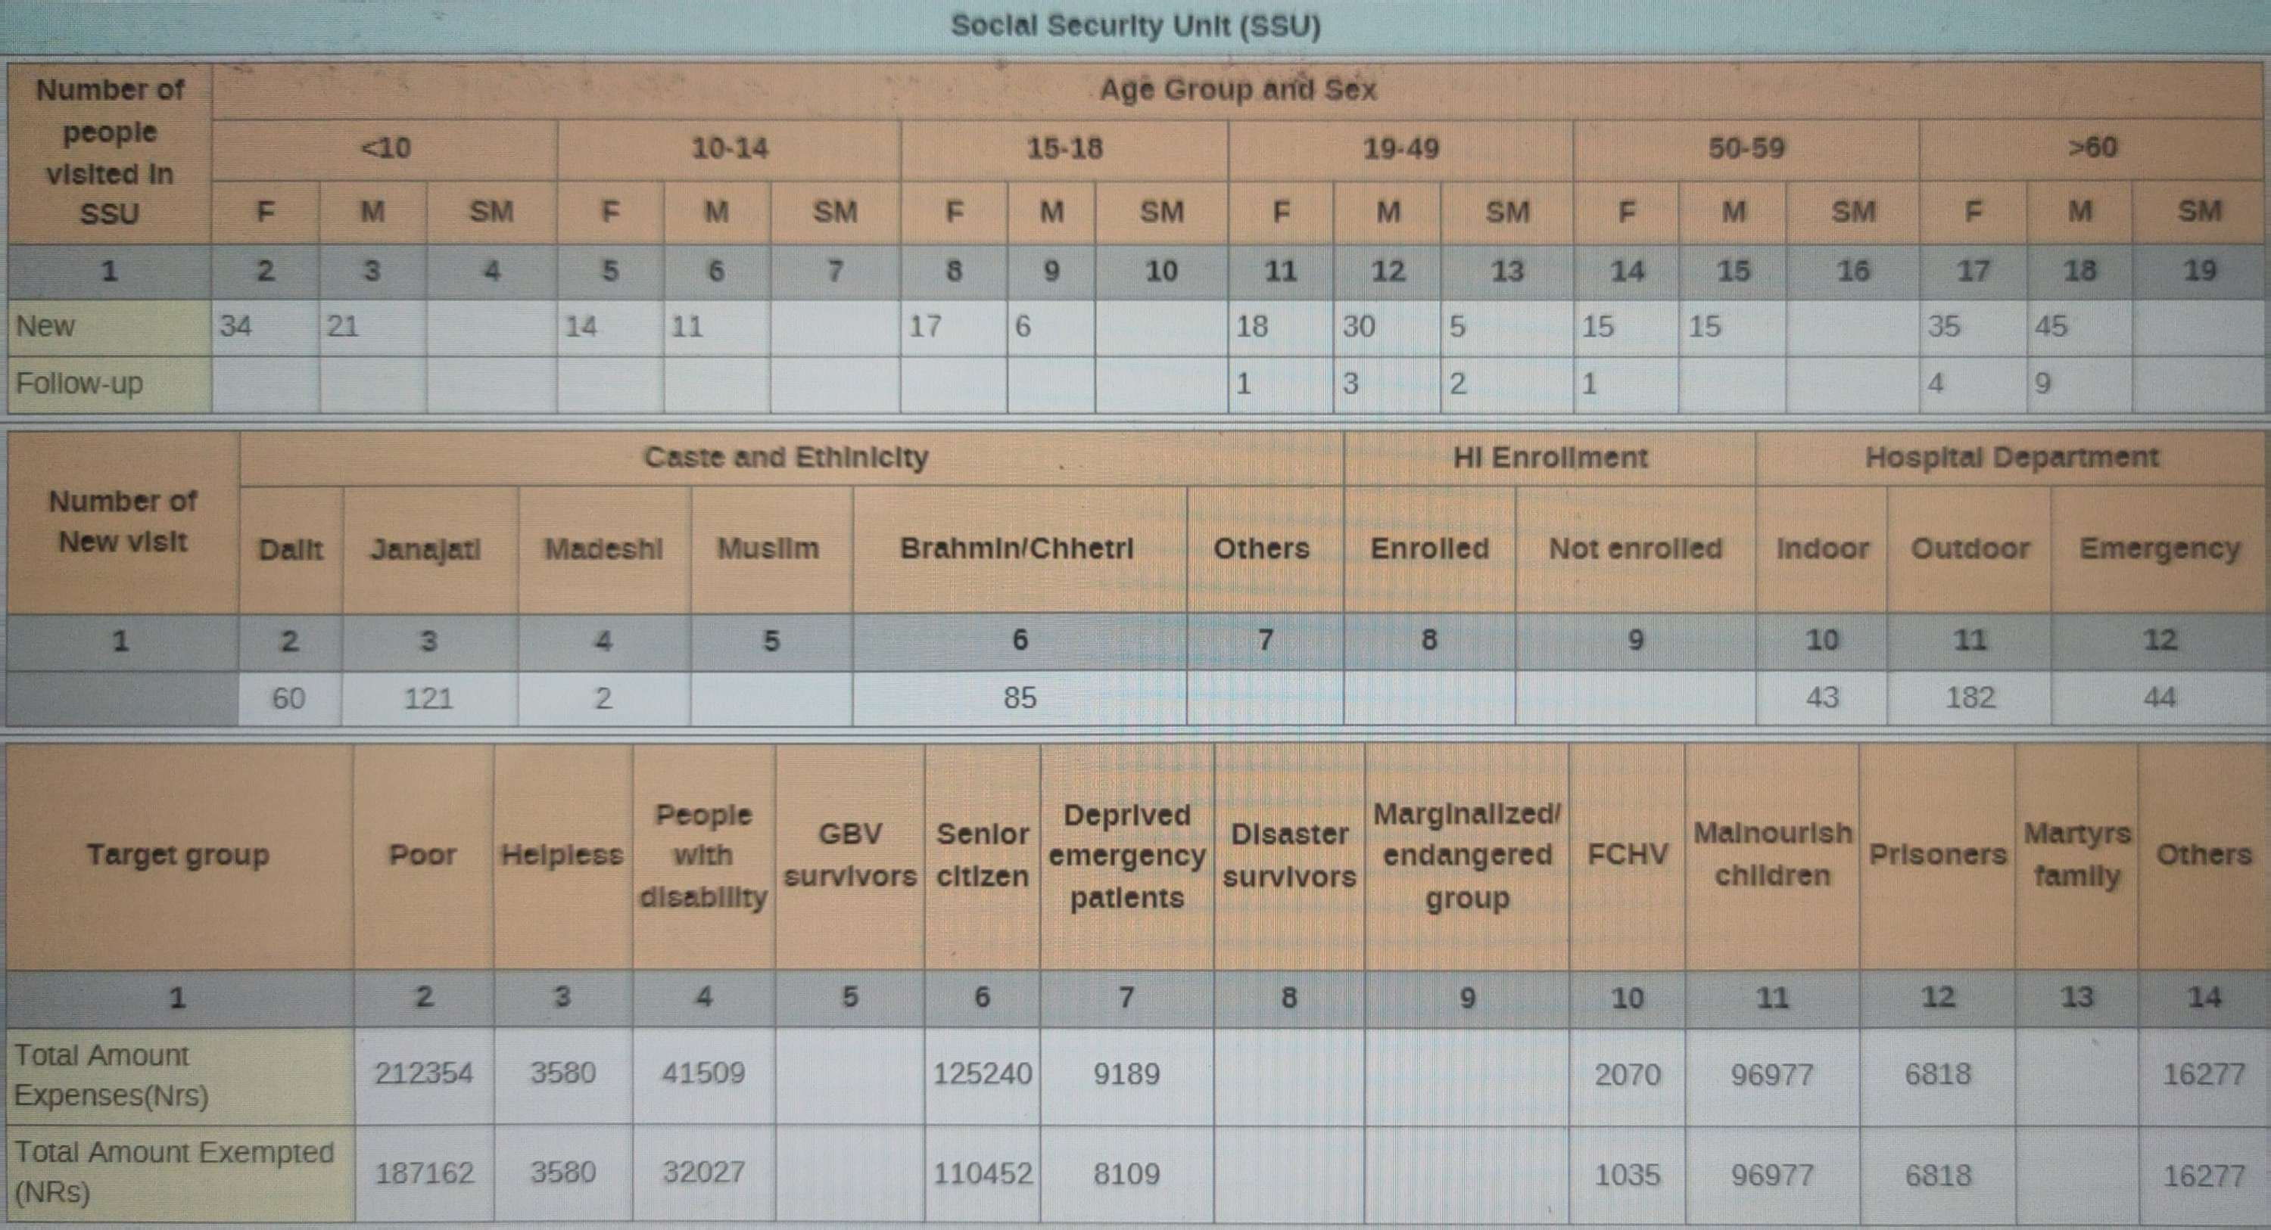

  - OCMC Service FY:081/082

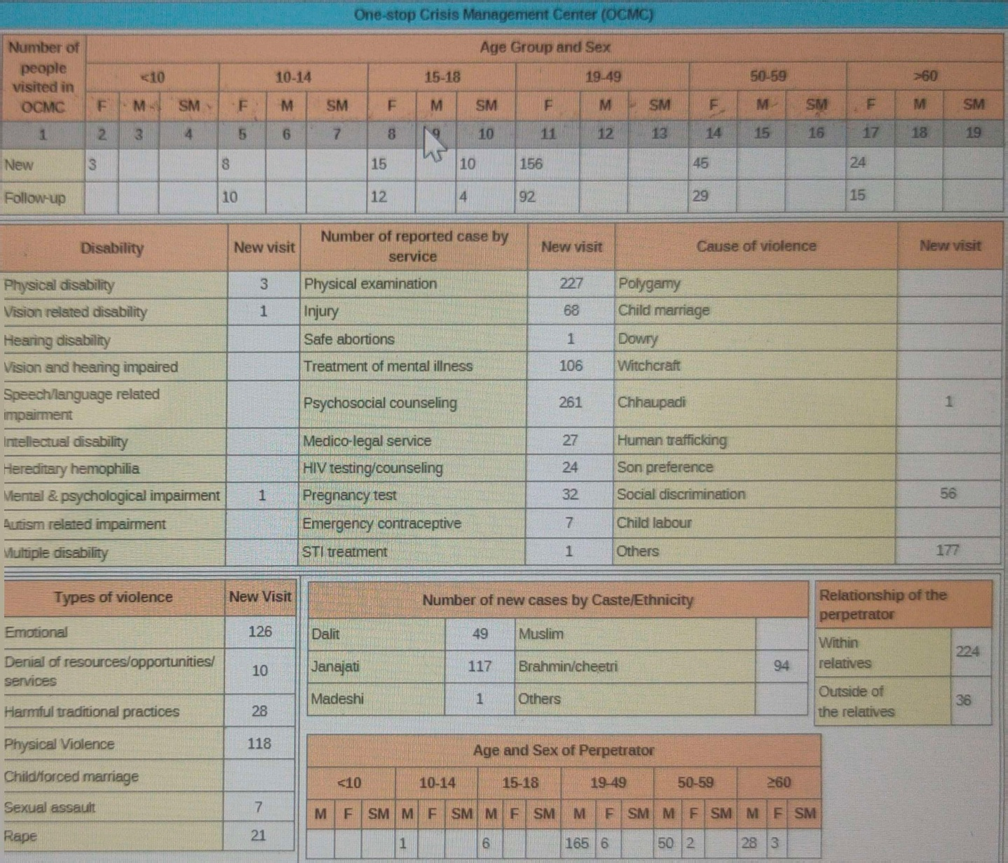

  - Three Years Trend of Diagnostic/Other Services.

Diagnostic/Other Services | Unit | 2079/80 | 2080/81 | 2080/81
X-ray | Number | 578 | 927 | 422
Ultrasonogram (USG) | Number | 232 | 118 | 321
Electrocardiogram (ECG) | Number | 186 | 298 | 379
Total Laboratory service Provided | Persons | 1969 | 2432 | 3244

  - Three Years Trend of Neonatal Deaths, Still Births,Maternal Death.

Categories | 2079/80 | 2080/81 | 2080/81
Neonatal Death | 0 | 0 | 0
Total Still births | 0 | 0 | 0
Still Birth: Fresh | 0 | 0 | 0
Still birth: Macerated | 0 | 0 | 0
Maternal Death | 0 | 0 | 0

  - Three Years Trend of Delivery by types

  - Obstetric Complications

Obstetric Complications | ICD Code | Number
Obstetric Complications | ICD Code | 2079/80 | 2080/81 | 2081/82
Ectopic pregnancy | JA01
Abortion complication | JA05 | 1 |  | 5
Pre-eclampsia | JA24
Eclampsia | JA25
Hyperemesis grivadarum | JA60.0
Antepartum haemorrhage | JA41
Prolonged labour | JB03 |  |  | 7
Obstructed Labor | JB06 |  |  | 1
Gestational Hypertension | JA23
Ruptured uterus | JB0A.1
Postpartum haemorrhage | JA43 | 5 |  | 8
Retained placenta | JA43.0 | 6 |  | 1
Pueperal sepsis | JB40.0 |  |  | 1
C-Section Wound Infection | JB40.1 | 1
Other complications | JB0Y | 91 | 51 | 2

  - Three Years Trend of Family Planning New acceptors

New Acceptors | 2079/80 | 2080/81 | 2081/82
Pills | 32 | 25 | 25
Depo | 90 | 66 | 66
IUCD | 0 | 9 | 9
Implant | 23 | 37 | 37
Sterilization | 0 | 0 | 0

Current User | 2079/80 | 2080/81 | 2081/82
Condom | 153 | 126
Pills | 628 | 38 | 126
Depo | 204 | 68 | 38
IUCD | 2770 | 1256 | 68
Implant | 153 | 126 | 1256
Sterilization | 0 | 2
  - Three Years Trend of Safe abortion services

Fourty client received safe abortion service in fiscal year 2081/82.

  - Nutrition Rehabilitation Centre Case Reported in FY:2081/82

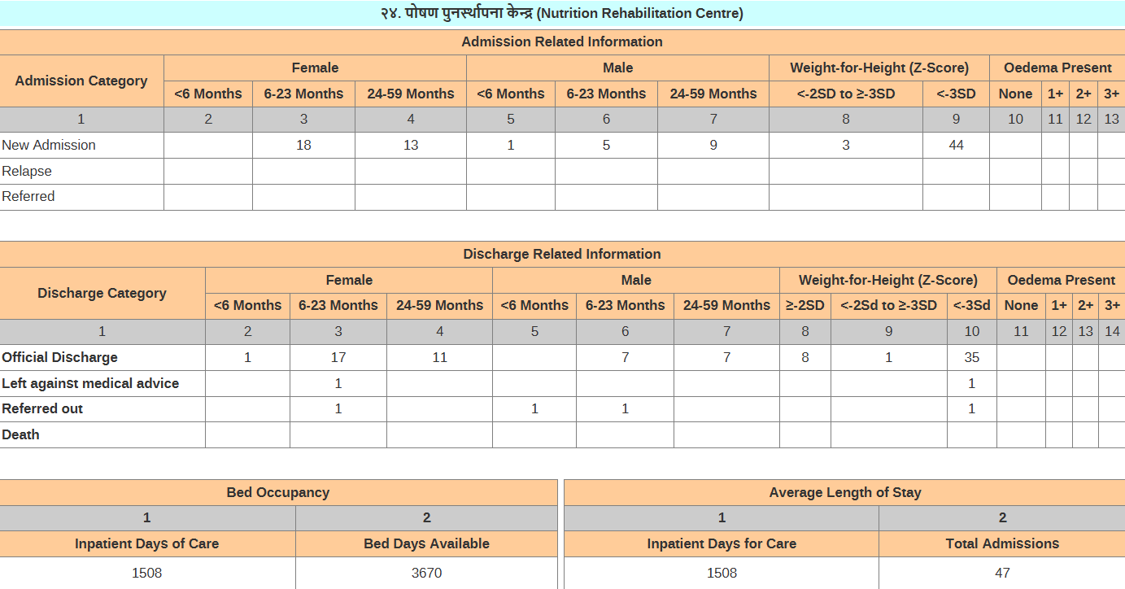

  - Reprort On Ewars FY:2081/82

Disease Name | Case In Number
AGE | 79
Dengue | 35
E.Fever | 3
Scrub Thyphus | 41

  - MSS Score History

12. आ.ब. २०८१/८२ मा गरेको मुख्या कार्यहरु
- 1. Complete Implementation of EMR System
- 2.Initiation of e-attendence

12.2 आ.ब. २०८२/८३ मा गर्नुपर्ने मुख्या कार्यहरु

- Lack of Anesthesia Assistant, other consultants ,trained staff and other human resources to start Major Operation .
- SNCU/Major OT /ICU setup completed but not functioning.
- Ambulance service is not available.
- Blood Bank is not available.
- Lack of timely maintenance of medical equipments.
- Generator is not adequate for hospital run.
- Inadequate Hospital waste Management .
- Hospital own canteen is not available.

- Contact Number Of Hospital Staff

Doctors
S.N. | Name | Designation
1 | Dr. Ravi kumar yadav | Act. Medical Superitendent
2 | Dr. Balaraj rai | Medical Officer
3 | Dr. Kiran ghishing | Medical Officer
4 | Dr. Samir shiwakoti | Medical Officer
5 | Dr.sugam ale magar | Medical Officer
SSU
6 | Sita dhamala | AHW
7 | Laxmi ghimire | ANM
8 | Preskila rai | ANM
Indoor
9 | Ranjana gurung | SANM
10 | Kalpana sunuwar | SANM
11 | Nirmala dahal | Staff Nurse
12 | Dhana adhikari | Staff Nurse
13 | Dhan maya lama | Staff Nurse
14 | Ngima kanchhi sherpa | b.sc.n
15 | Laxmi dahal | Staff Nurse
16 | Nikita dahal | Staff Nurse
17 | Ashmita b.k. | Staff Nurse
18 | Tulsha gurung | ANM
19 | Sarana gurung | ANM
20 | Alisha karki | ANM
21 | Urmila b.k. | ANM
22 | Jayanta dhamala | ANM
23 | Anushka rai | ANM
24 | Dutt maya b.k. | AWH
25 | Gita dahal | AWH

Lab
26 | Rajesh sah | Lab Tech.
27 | Chandrashekhar kumar yadav | Lab Asst.
28 | Anuradha magrati | Lab Asst.
X-ray
29 | Sikendra kumar yadav | Dark Room Asst.
Healper
30 | Khilanath dhamala | Ka.sa.
31 | Bal bdr darji | Ka.sa.
32 | Badri babu pokhrel | Ka.sa.
33 | Rajkumar shrestha | Ka.sa.
34 | Pabi shrestha | Ka.sa.
35 | Santoshi pariyar | Ka.sa.
36 | Lok bdr thapa magar | Ka.sa.
37 | Bina shrestha | Ka.sa.
38 | Kamala magar | Ka.sa.
39 | Ramkumari gurung | Ka.sa.
40 | Radhika gurung | भान्छे
41 | Sumitra gurung | भान्छे
42 | Juna gurung | भान्छे
43 | Tika maya darji | cleaner
44 | Bibek gurung | S.S
45 | Kumar ale magar | S.S
Security
50 | Rajan adhikari | Police

14 . photo

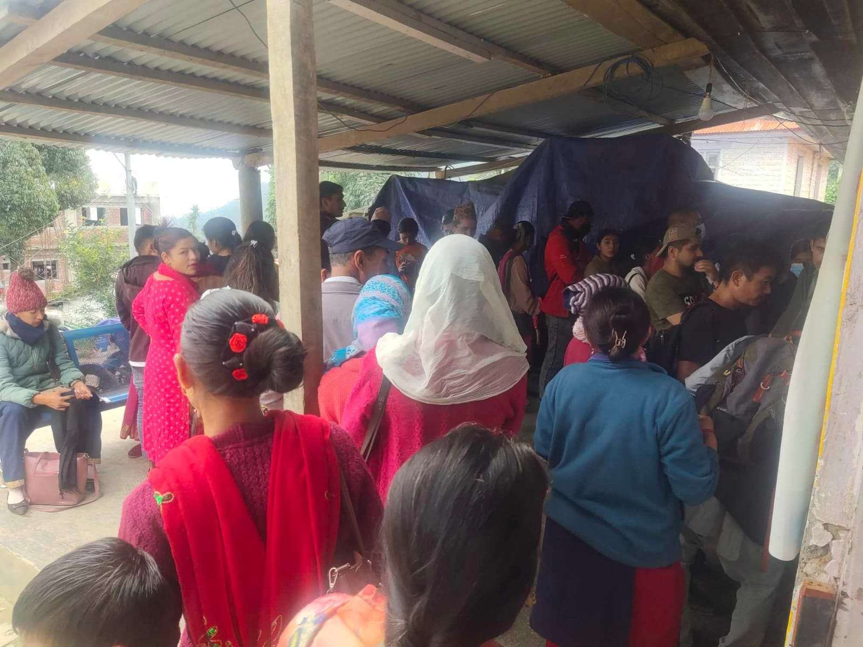

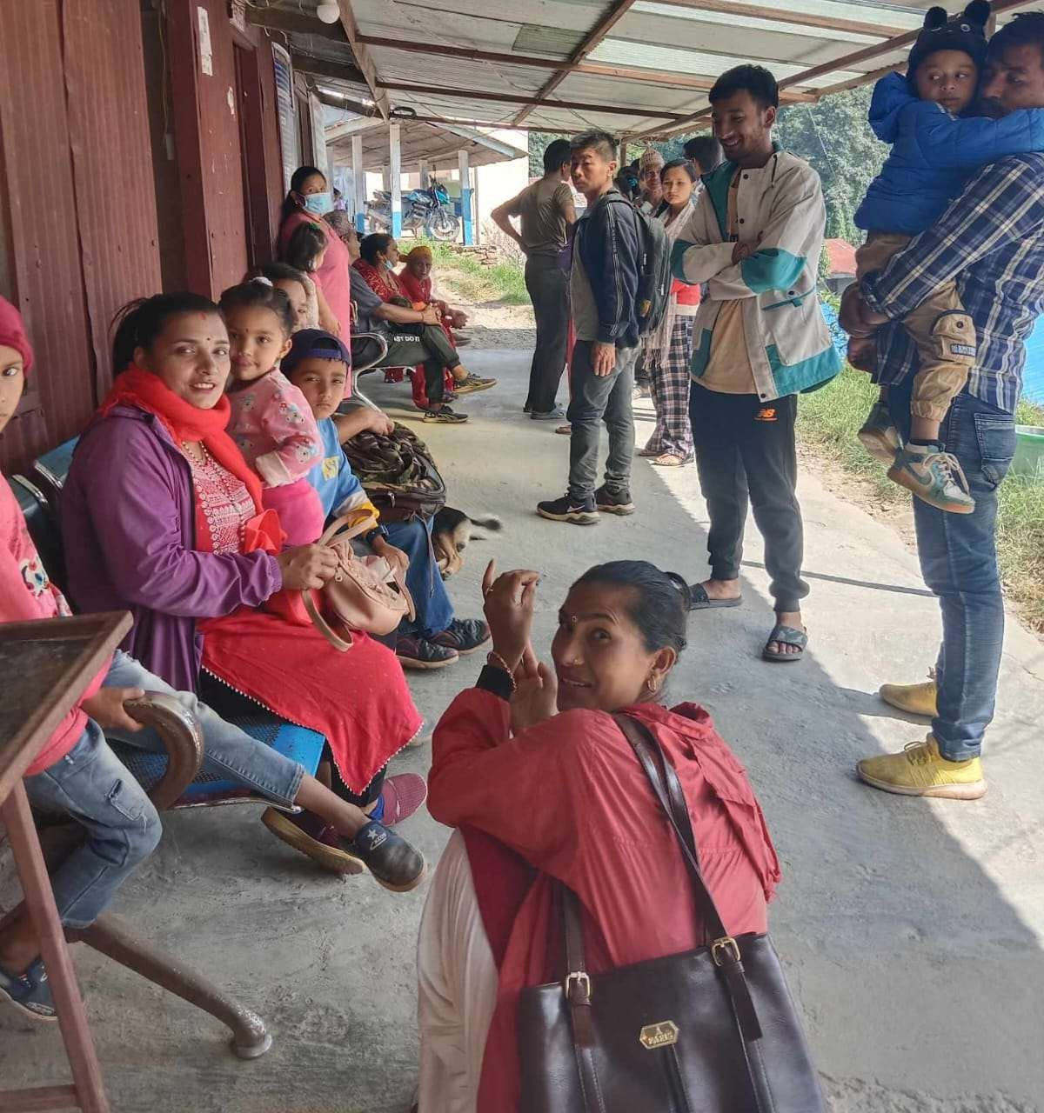
Patients Flow Emergency Department

Patients Flow Ticket Counter

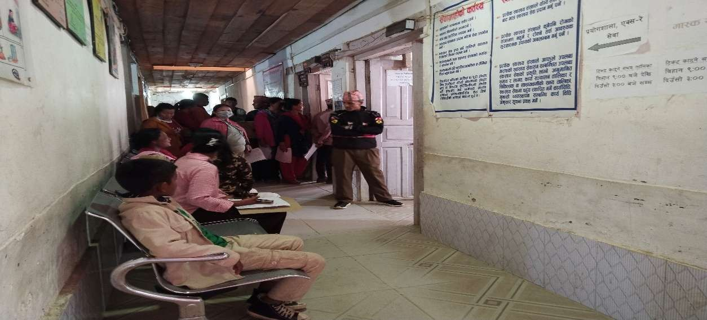
OPD Department

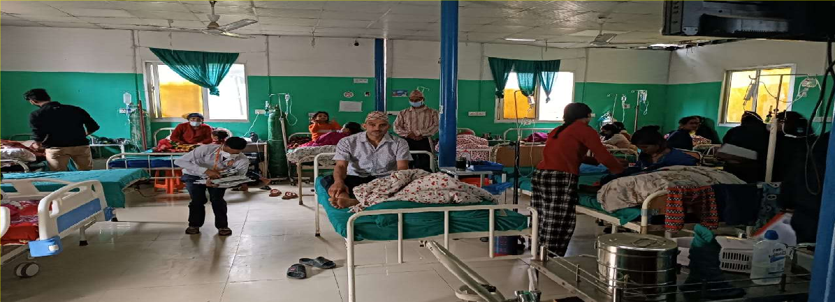
Indoor Department
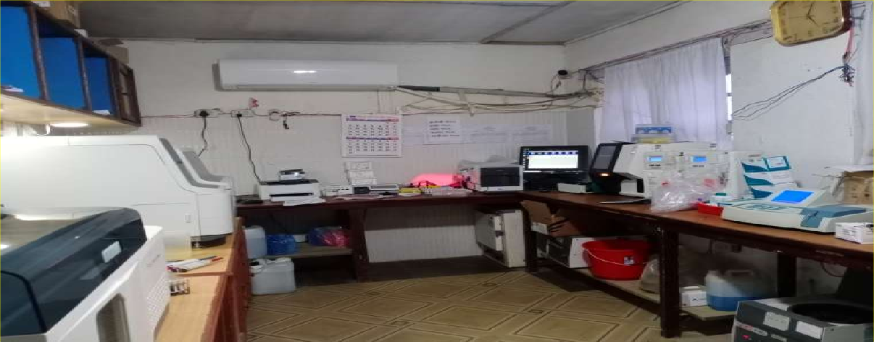
Lab Department

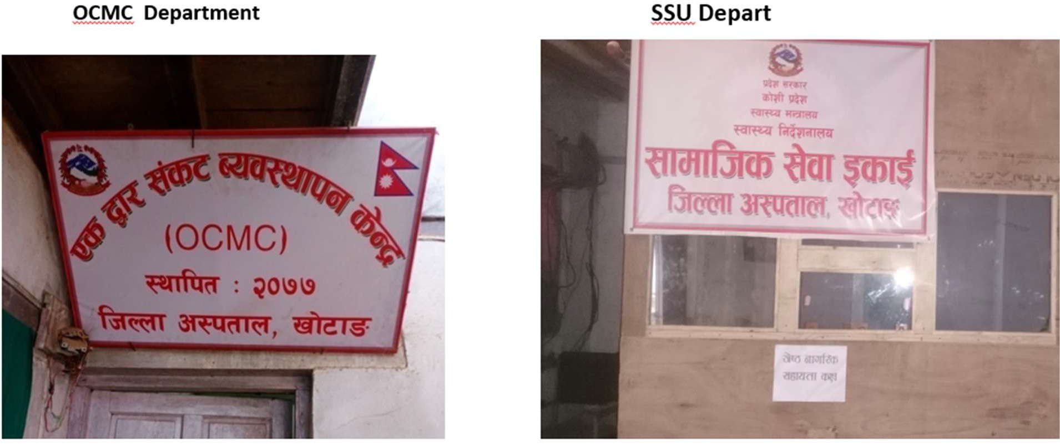
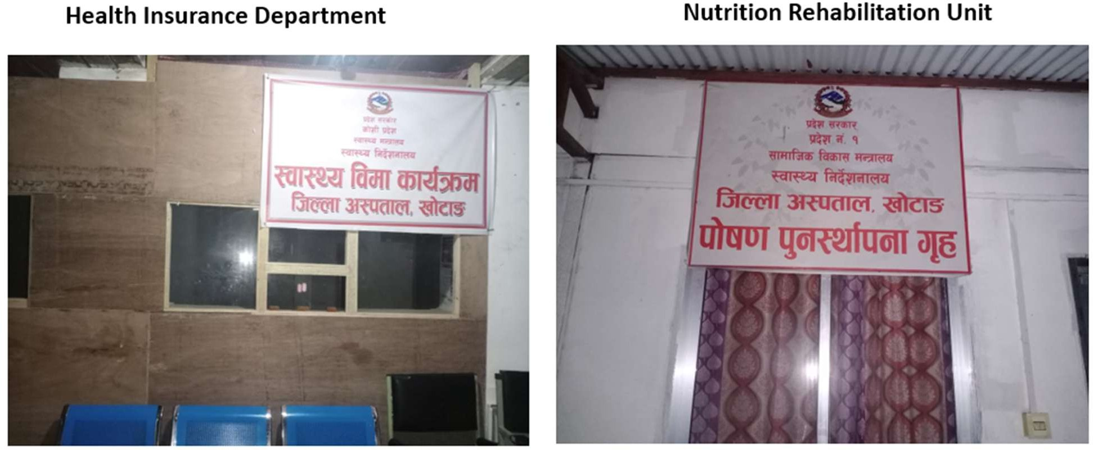
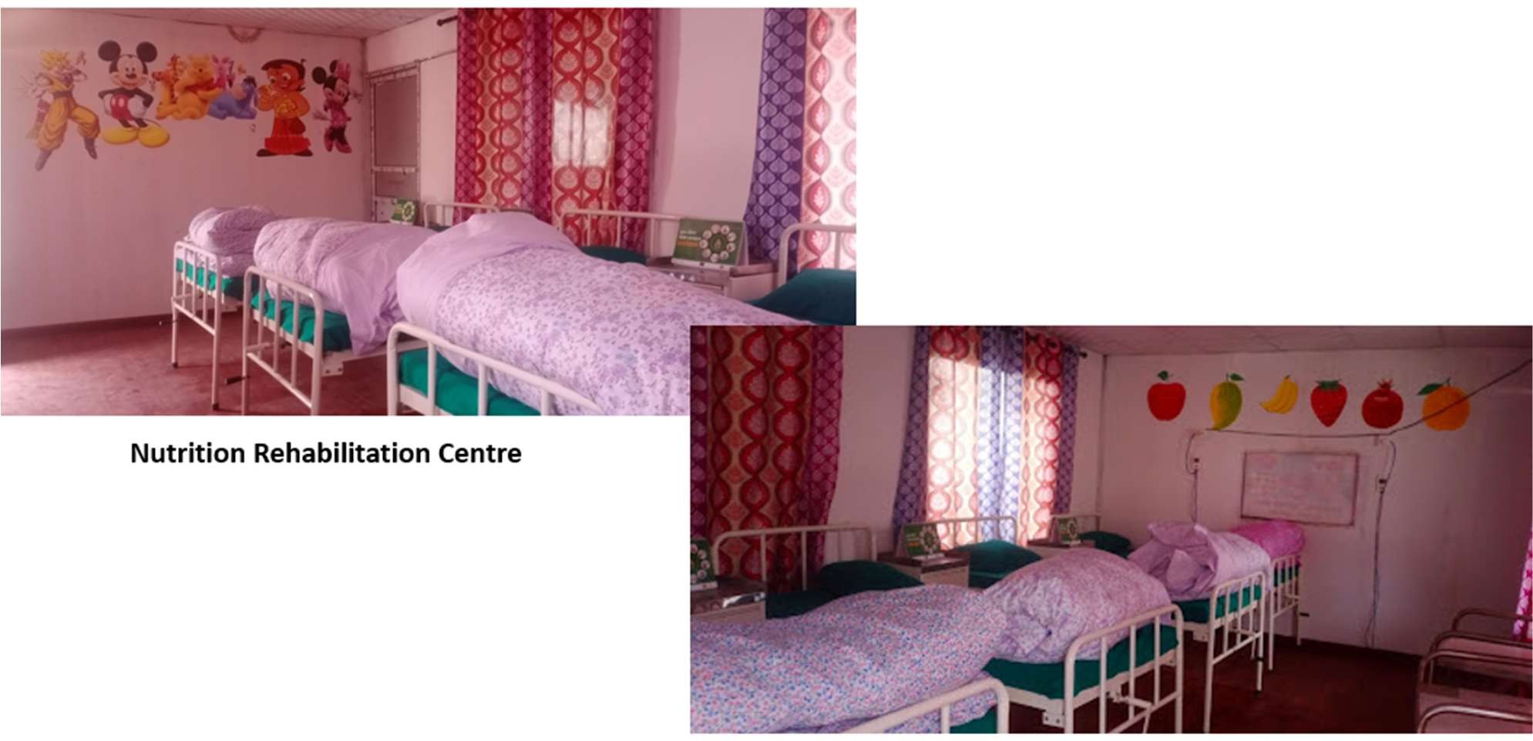

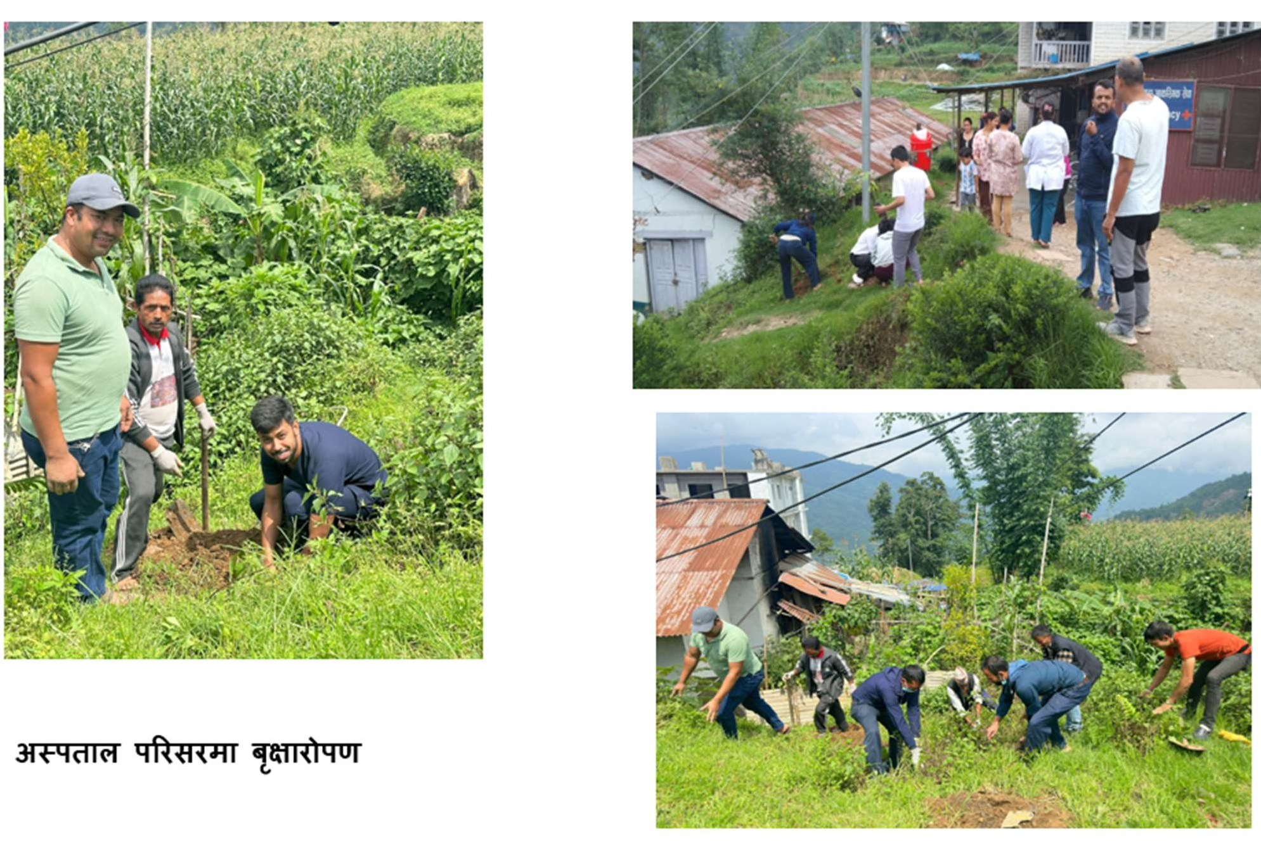
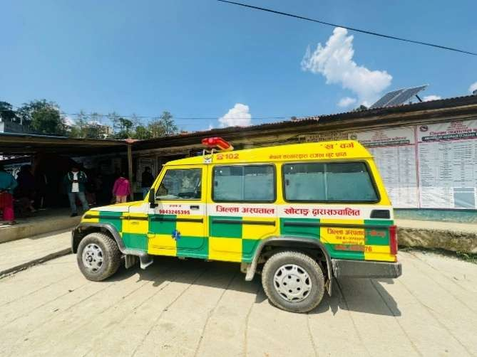
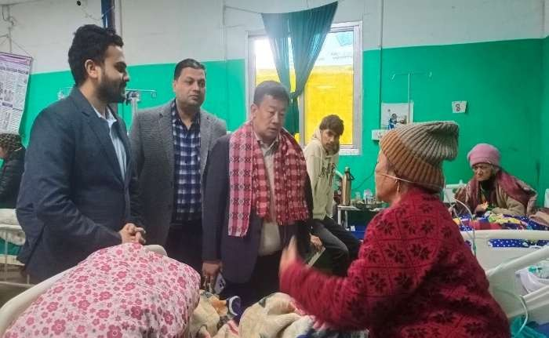
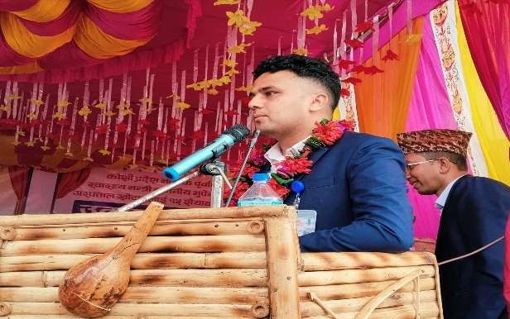
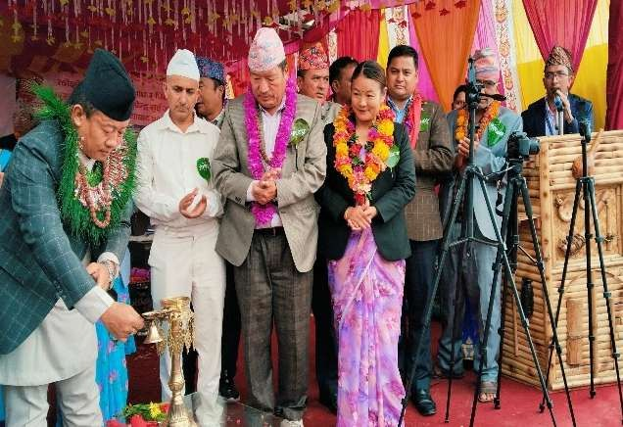
ख-Rग´Vो Ŋ’ब¸N`=W खǐरद R7निनय èR7è“यR=ğी भप¸ `=Y र7ई :य¸ Nèपत7NR7 भन7´ भŊVो िबर7RीWँग भ`Yघ7Y

R7निनय èR7è“यR=ğी भप¸ `=Y र7ई Ʈ7र7 ५O शɇय7 èतरोǏती

lhNnf c:ktfn cff]vn9'+uf,?Dhf6f/ jflifs k|ltj]bg @)*!÷)*@

Programme Events
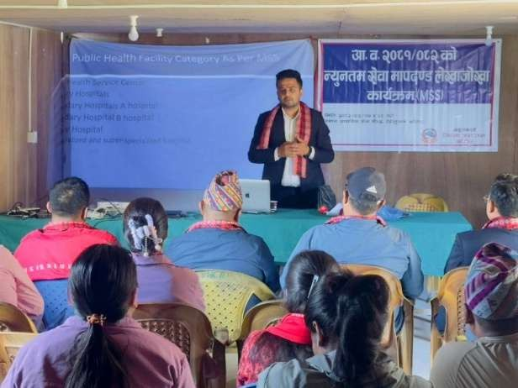
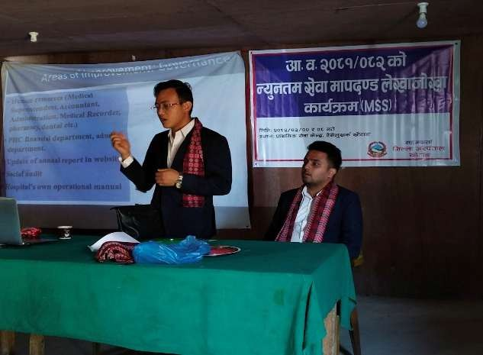
èfl7िनय त5Vो =य¸नतR W`R7 R7पदÖड - ऐW`N¸खV´ ग77ँप7िNV7
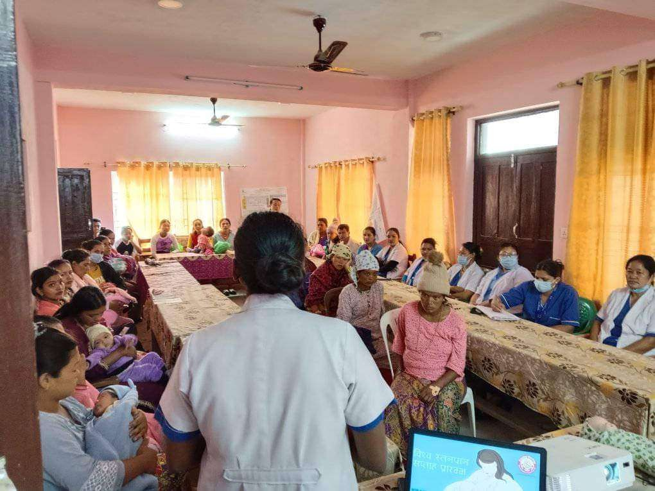
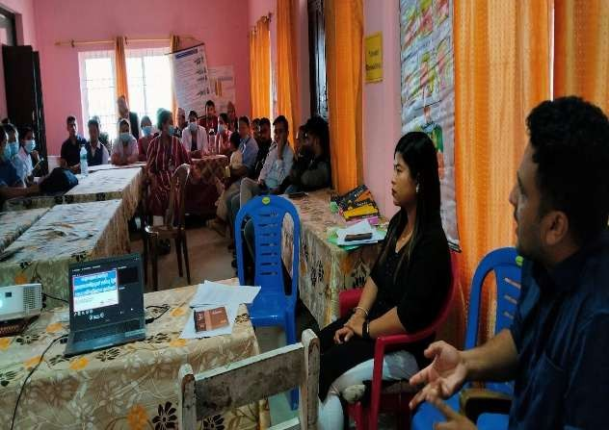
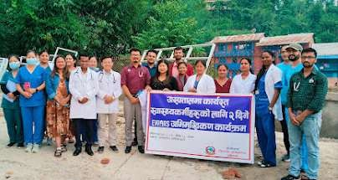
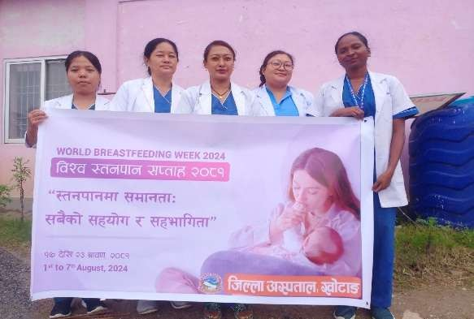
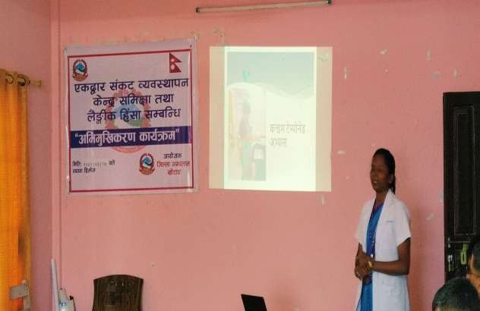
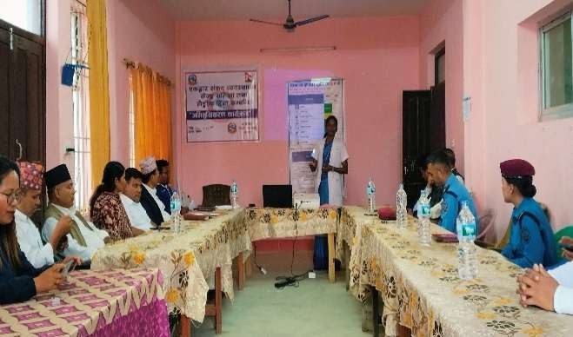
èR7è“यVRẺ55Vो N7िग EWARS NिभR¸िखVरÆ V7य´WR
ŊVƮ7र WंVY åयRèfl7पन V` =YVो WिR¢7 V7य´WR
èतनप7न WƯ75 V7य´WR Wंच7Nन

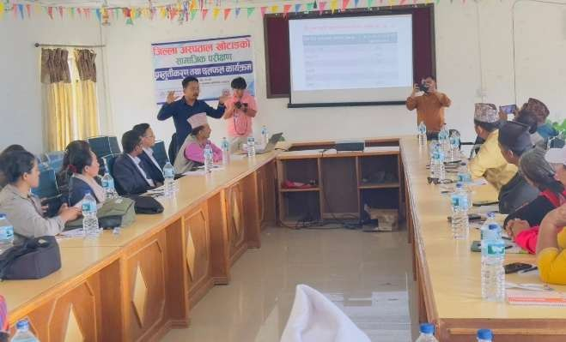

W7R7NीV N`ख7 पǐर¢Æ V7य´WR
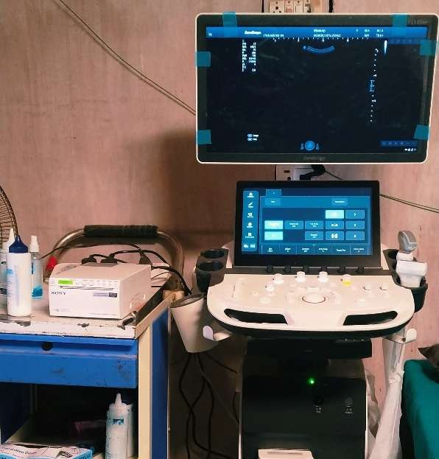
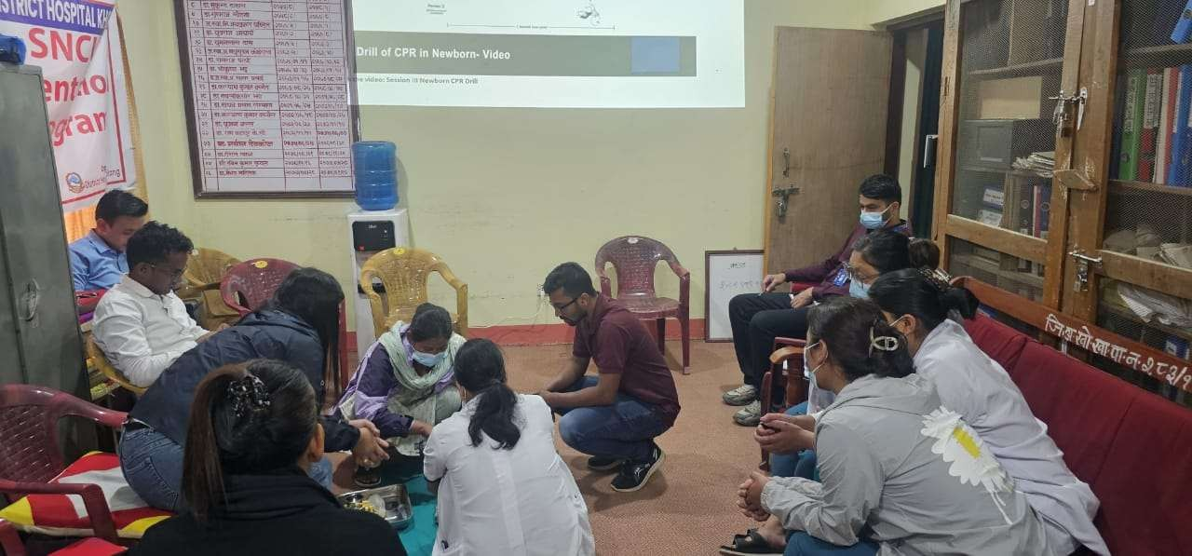
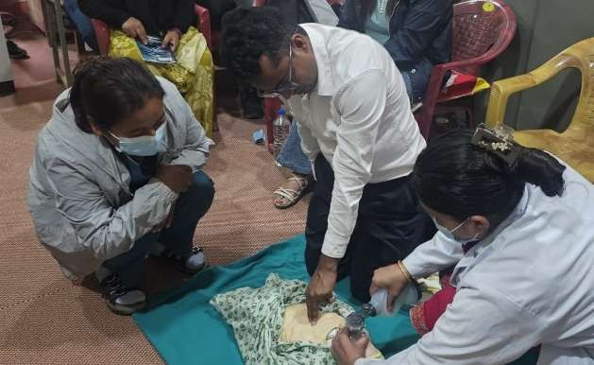
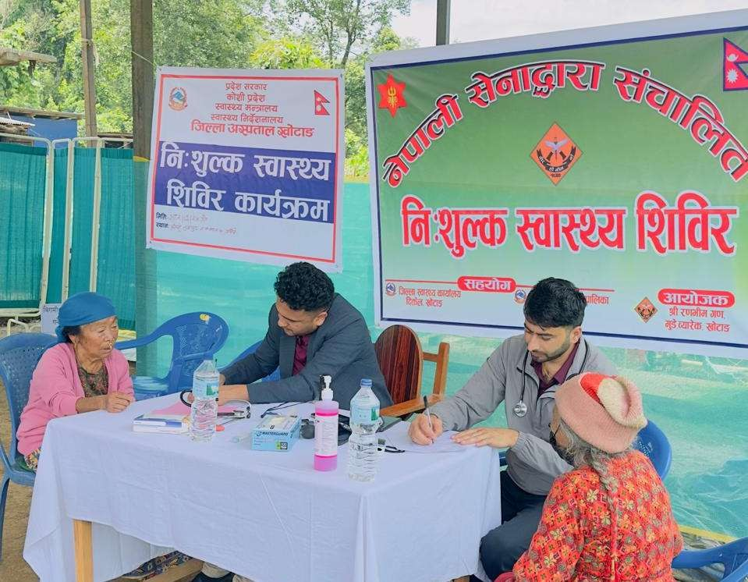
SNCU Orentation V7य´WR
िन:श¸ãV èR7è“य िशिबर V7य´WR Ĥद`श WरV7र R7फ´ त Ĥ7Ư नय7ँ िभिडयो ŊFWर` R`िWन

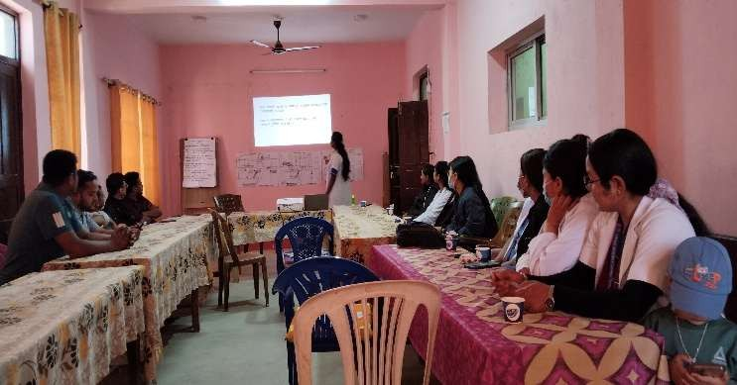
CME V¢7 Wंच7NनVो ŊV झNV
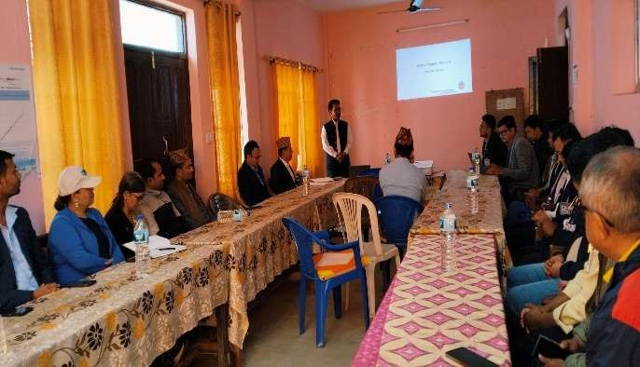
Nèपत7NVो =य¸नतR W`R7 R7पदÖड R˛ãय7ǋनV7 N7िग ब`9V Wंच7Nन
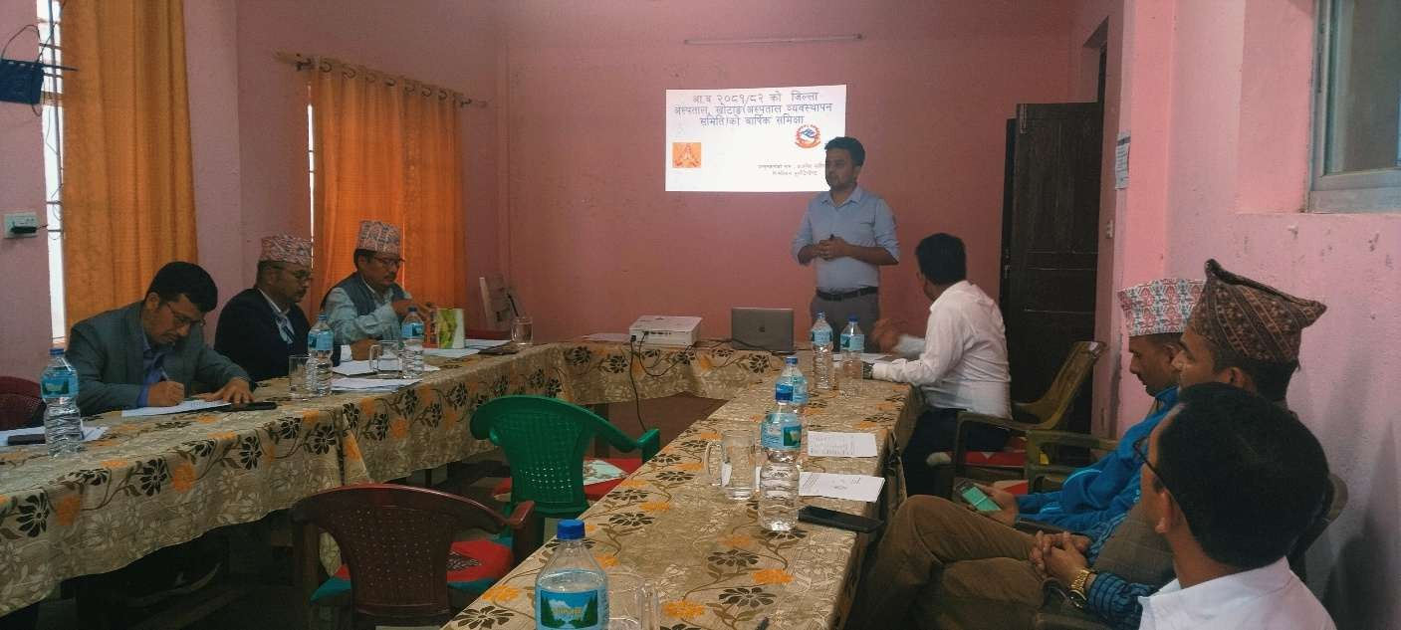
Nèपत7N åयRèfl7पन WिRित WR¢ R7ǒe´V Ĥगती Ĥèति¸ तVरÆ

Annex Abbreviations
AGE : Acute Gastro enteritis ANM :Auxiliary Nurse Midwife
ARI :Acute Respiratory tract Infection ART : Anti retro therapy
CBC :Complete blood count
COPD :Chronic Obstructive Pulmonary Disease DM :Diabetes mellitus
DOR :Discharged on Request ECG :Electrocardiogram
FY :Fiscal Year
GoN :Govern of Nepal
HIV :Human Immunodeficiency Virus ICU : Intensive Care Unit
IPD : Indoor Patient Department K : Potassium
Lab :Laboratory
LAMA : Left Against Medical Advice LFT :Liver Function Test
LRTI : Lower Respiratory Tract Infection MS : Medical Superintendent
Na :Sodium
NICU : Neonatal Intensive Care Unit OPD : Outdoor Patient Department OT : Operation Theater
PT INR : prothrombin time international normalized ratio.
RFT : Renal Function Test USG :Ultra sonogram
UTI : Urinary Tract Infectio

Annex Abbreviations
AGE : Acute Gastro enteritis ANM :Auxiliary Nurse Midwife
ARI :Acute Respiratory tract Infection ART : Anti retro therapy
CBC :Complete blood count
COPD :Chronic Obstructive Pulmonary Disease DM :Diabetes mellitus
DOR :Discharged on Request ECG :Electrocardiogram
FY :Fiscal Year
GoN :Govern of Nepal
HIV :Human Immunodeficiency Virus ICU : Intensive Care Unit
IPD : Indoor Patient Department K : Potassium
Lab :Laboratory
LAMA : Left Against Medical Advice LFT :Liver Function Test
LRTI : Lower Respiratory Tract Infection MS : Medical Superintendent
Na :Sodium
NICU : Neonatal Intensive Care Unit OPD : Outdoor Patient Department OT : Operation Theater
PT INR : prothrombin time international normalized ratio.
RFT : Renal Function Test USG :Ultra sonogram
UTI : Urinary Tract Infection

