Referenced From https://mocit.gov.np/
Our site link: https://gorkhapatra8wekp0.giwms-admin.gov.np/

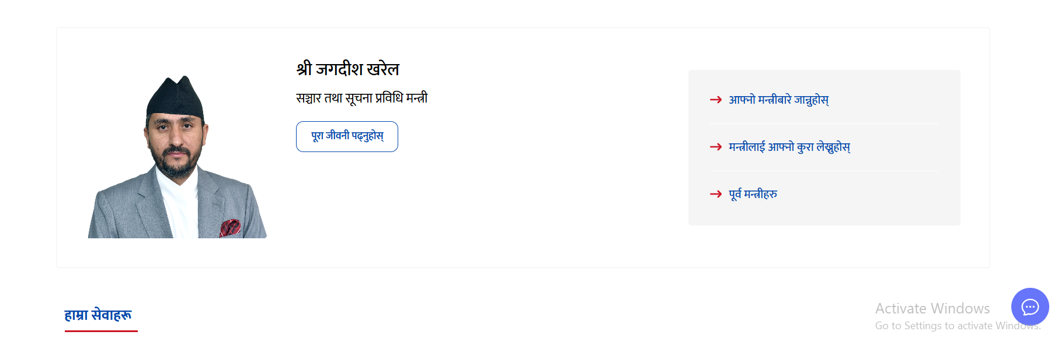

How to make this part
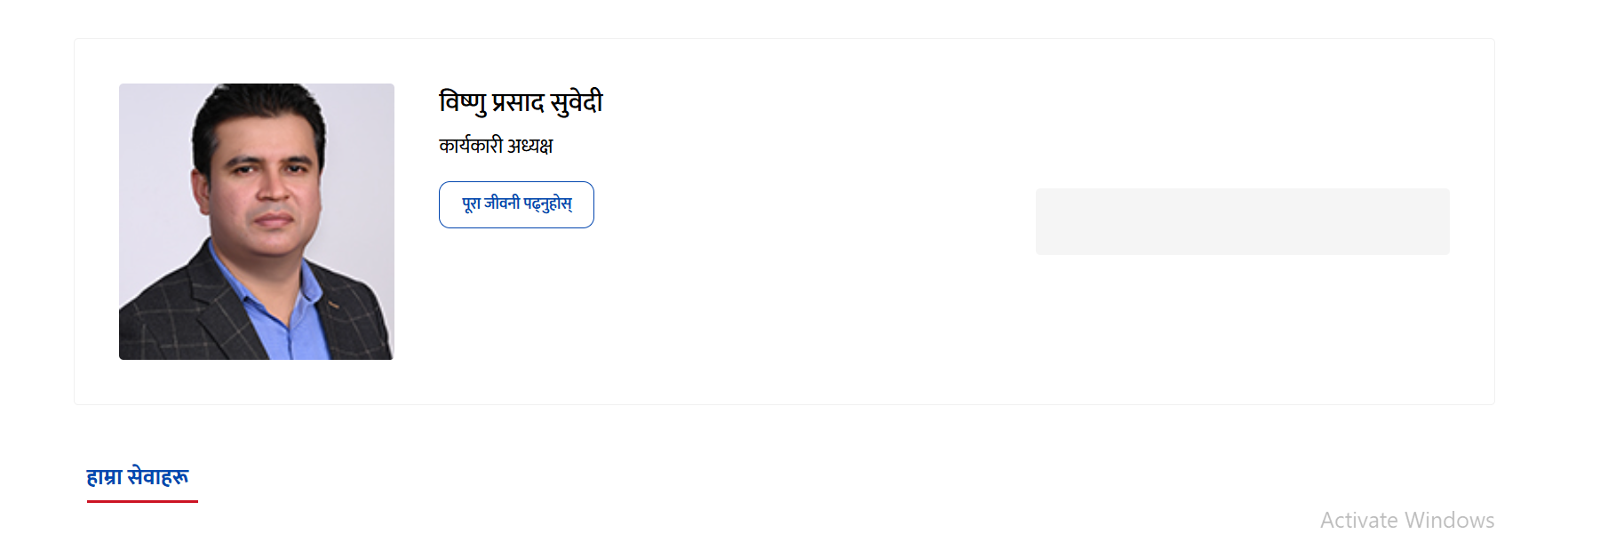
In gorkhapatra

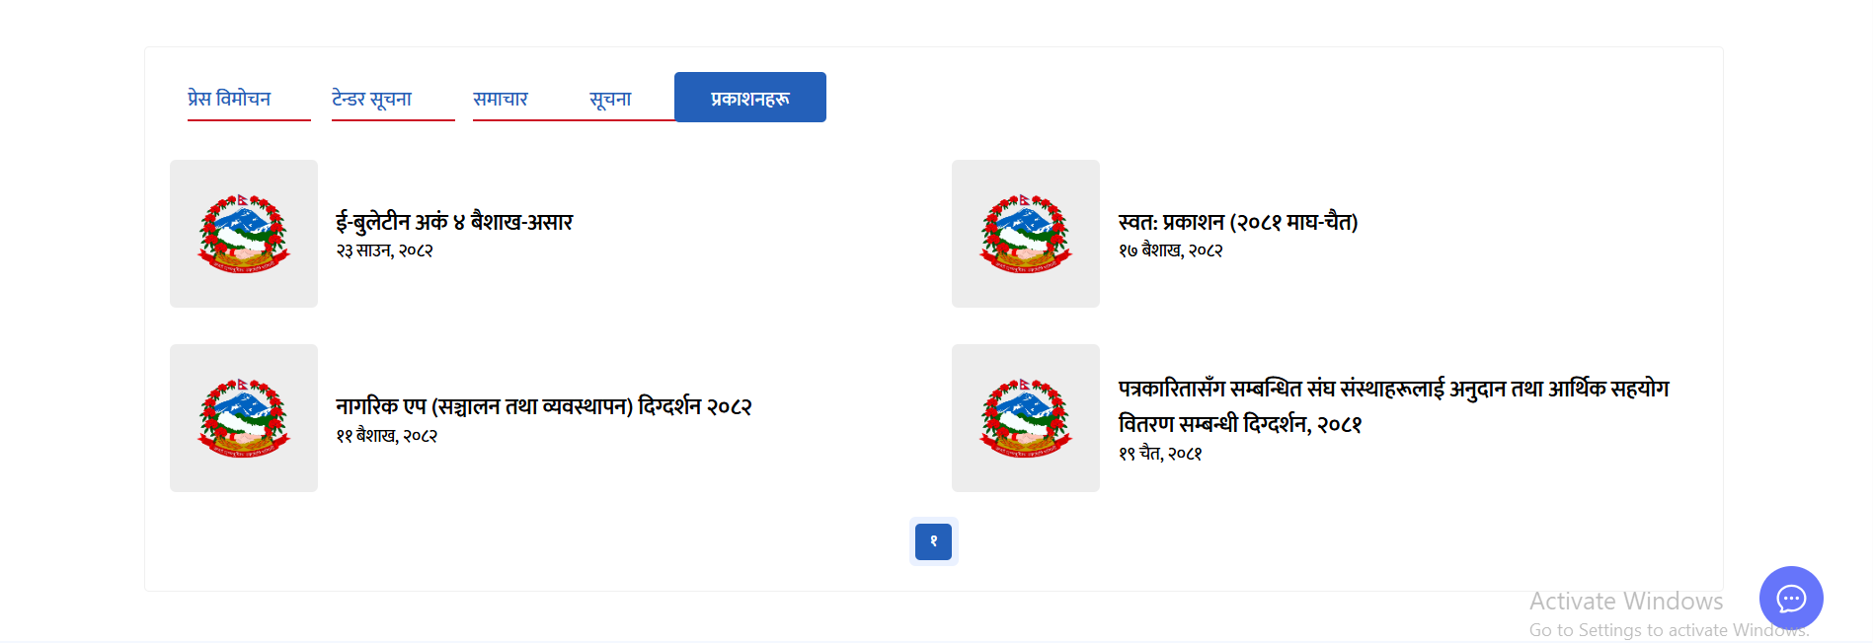
We need this part , how to show , if exist

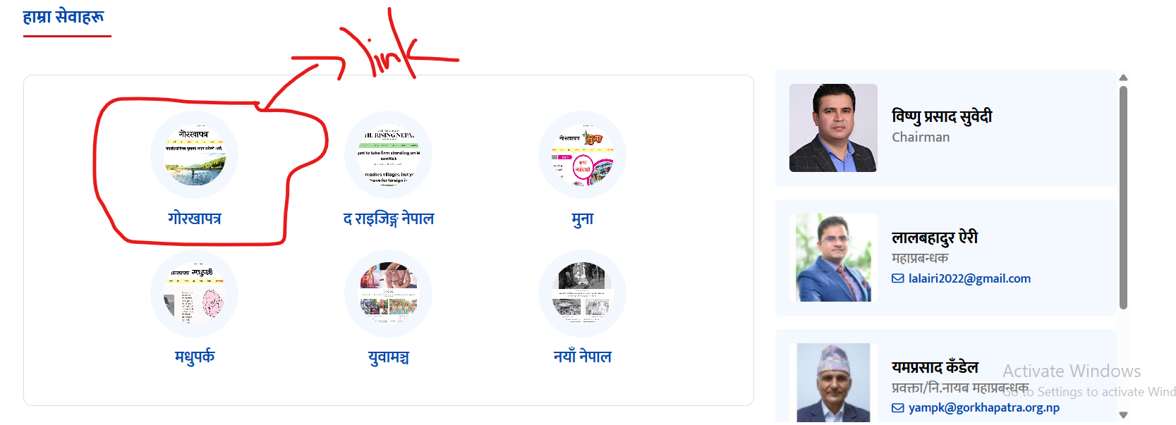
This portion here should go to our gorkhapatraonline website, this should open in new page

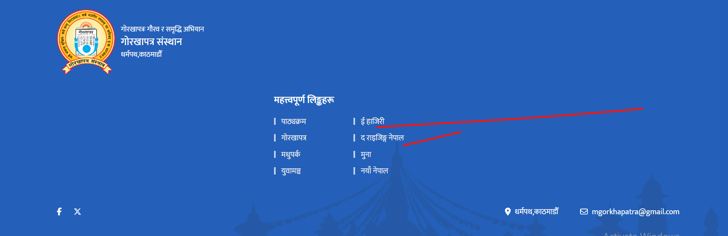
On clicking this of footer , it should open in new tab , now opening at same screen

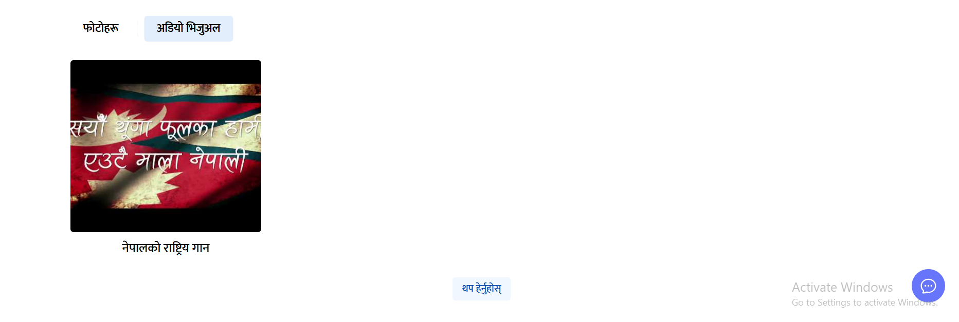
We need this part, we have only photo haru

